- The Smiths remodeled their living room, making is more formal. They used gold and yellow tones to create this new look. Which color scheme did they use?
  - Monochromatic
  - Analogous
  - Complementary
  - Accented neutral
- Yolanda decorated her kitchen with denim chair covers, green wall paint, and a blue-green checkered border on the wall. Which color scheme did she use?
  - Complementary
  - Triad
  - Analogous
  - Accented neutral
- Which element of design helps to lead eye movement by giving direction?
  - Line
  - Color
  - Texture
  - Shape
- To create the illusion of warmth, which colors should be selected?
  - Blue, green, and violet
  - Red, orange, and yellow
  - White, black, and gray
  - Red, white, and blue
- Red-orange, red, and red-violet used together illustrates which color scheme?
  - Complementary
  - Analogous
  - Triad
  - Accented neutral
- Which defines fabric texture?
  - Silhouette
  - Hue
  - Look and feel
  - Size and shape
- Adding white to a color creates a:
  - Shade
  - Triadic color
  - Tint
  - Neutral
- What results when the elements or design are used effectively according to the principles of design?
  - Harmony
  - Intensity
  - Formality
  - Happiness
- Adding black to a color creates a:
  - Tint
  - Value
  - Neutral
  - Shade
- The center of attention in a living room is the large family portrait over the fireplace. This is an example of:
  - Balance
  - Proportion
  - Rhythm
  - Emphasis
- The elements of design include:
  - Proportion, balance, emphasis, and rhythm
  - Color, line, shape, and texture
  - Balance, color, line, and texture
  - Emphasis, shape, line, and rhythm
- Which are the primary colors?
  - Blue, green, and violet
  - Green, red, and orange
  - Orange, green, and purple
  - Yellow, blue, and red
- To create a dramatic and richly influenced room, which color should be used in decorating?
  - Blue
  - Purple
  - Red
  - Orange
- The principles of design include:
  - Color, line, shape, and texture
  - Emphasis, shape, line, and rhythm
  - Proportion, balance, emphasis, and rhythm
  - Balance, proportion, line, and texture
- Which color group is considered to be calm, relaxing, and soothing?
  - Monochromatic
  - Neutral
  - Cool
  - Warm
- Maria's sweater has vertical lines on the right side and circles on the left. Which principle of design is being illustrated?
  - Balance
  - Repetition
  - Structural texture
  - Added visual texture
- The lightness or darkness of the blue in Alyssa's skirt is referred to as the:
  - Intensity
  - Tint
  - Proportion
  - Value
- Using violet, orange and green in a room would illustrate which color scheme?
  - Triad
  - Complementary
  - Monochromatic
  - Analogous
- Short people should avoid which type of line?
  - Curved
  - Diagonal
  - Horizontal
  - Vertical
- A customer who does not like attention should wear:
  - ? Bright colors
  - ? Busy prints
  - ? Earth tones
  - ? Shiny textures
- The term hue means:
  - Color
  - Tint
  - Shade
  - Value
- Which of the following are additive primaries?
  - Red, Yellow, Blue
  - Red, Green, Blue
  - Cyan, Yellow, Magenta
  - Red, Yellow, Green
- In web design, a number between 1-255 designates the amount of each
  - Color
  - Tint
  - Shade
  - Value
- Contrast is the juxtaposition of ALL of the opposing elements EXCEPT:
  - Colors
  - Value
  - Repetition
  - Direction
- Negative space has of ALL of the purposes EXCEPT:
  - To provide organization
  - To create movement
  - To promote dominance
  - To hinder direction
- The following is an example of
  - Dominance
  - Value
  - Balance
  - Direction
- The following is an example of 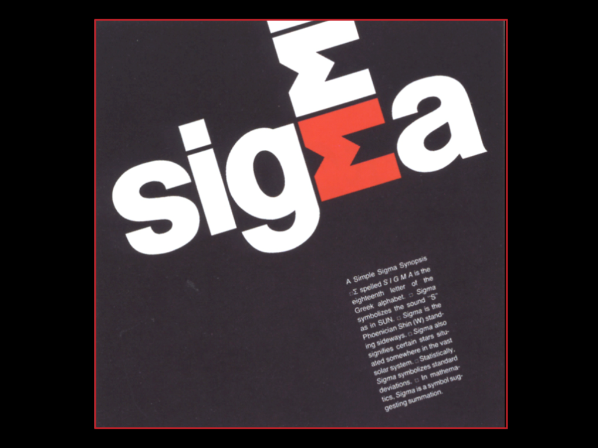
  - Contrast
  - Repetition
  - Balance
  - Value
- The following is an example of
  - Dominance
  - Value
  - Balance
  - Direction
- The following is an example of 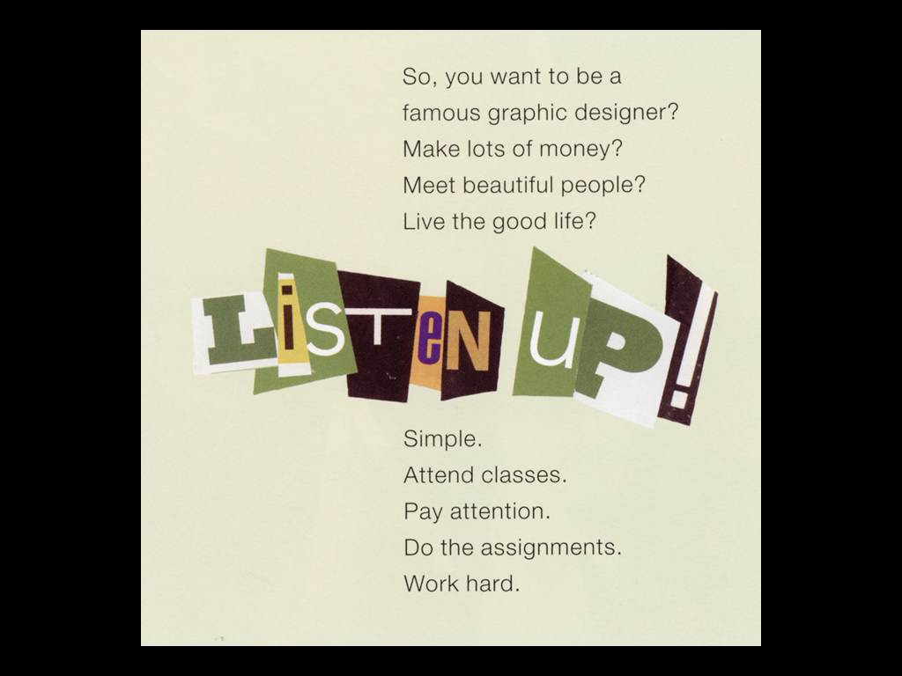
  - Unity
  - Value
  - Balance
  - Contrast
- The following is an example of 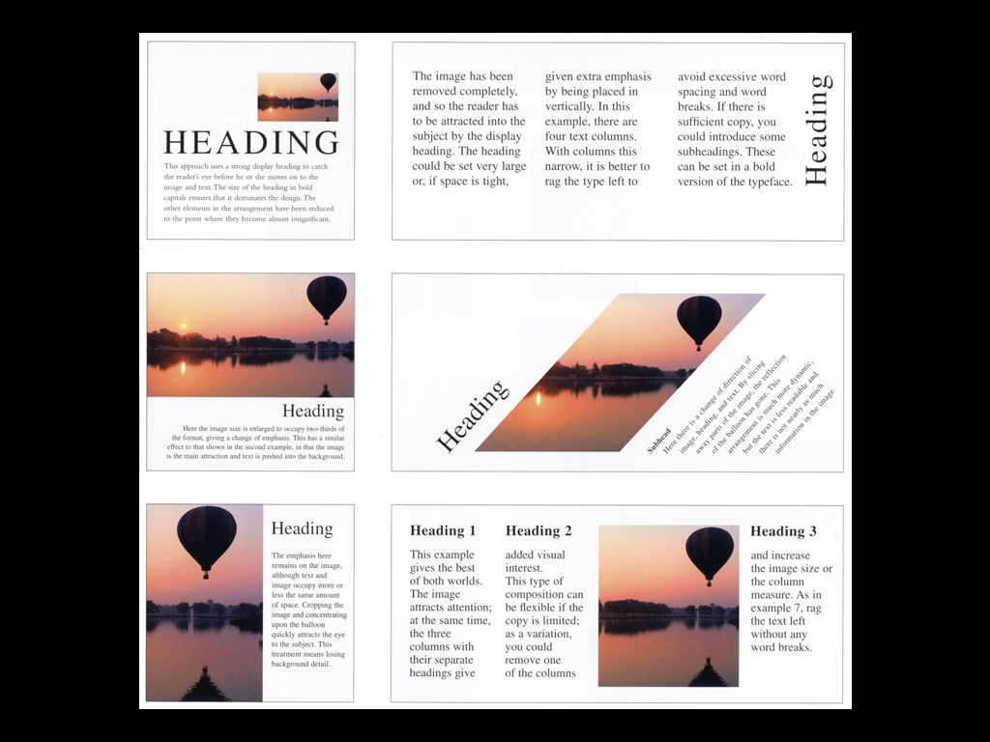
  - Unity
  - Value
  - Balance
  - Contrast

