Rise of Totalitarianism

Analyze the first two documents to answer questions # 1-4.
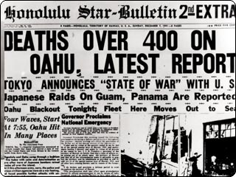
As the American embargoes on oil strained the Japanese economy, Prime Minister Hideki Tojo insisted that if the United States and Japan cannot negotiate, then Japan would have to fight. In addition to this, the Japanese were convinced that they’d have to fight the United States anyway to secure access to the raw materials of European colonies in Southeast Asia.
-Gary D. Allinson; Professor of Modern Japanese History

- What did economic precedence suggest of Hideki Tojo’s concern with power?

- According to the newspaper document above, it states that Japan had raided Guam and Panama as well. To what extent was Hideki Tojo’s military aggression a totalitarian act? And justify why his actions are viewed as aggressive totalitarianism.

- How far do you think totalitarian rulers go to acquire power?

- It is said that Hideki Tojo’s act on Pearl Harbor was unjust and treachery, though Hideki Tojo claim it was all done to release the stain on his economy. Do you agree or disagree with Hideki Tojo’s actions on attacking Pearl Harbor?

Analyze the next document to answer questions # 5-6.
Tojo was a militarist, believing that military interests should be foremost. The Manchurian Incident was an event where an explosion occurred on a Japanese-run railway in Manchuria in 1931. It was blamed to the Chinese by militarists to use as an excuse to occupy Manchuria. This ultimately led to the aggression of the Sino-Japanese War (1937-1945). Then, the United States imposed economic pressure to the Japanese to halt the Japanese aggression.
Modern Japanese History

- Now according to this above passage, what do you now think of the Japanese trying to free themselves of economic strain by the United States?

- Is it safe to say that militaristic ideology parallels with totalitarianism? Explain.

Analyze the next set of documents to answer questions # 7-10.
“It goes without saying that when survival is threatened, struggles erupt between peoples, and unfortunate wars between nations result.”
-Hideki Tojo

Tojo was known to have major influence on Emperor Hirohito as general. In fact, Konoe, the Prime Minister before Tojo said this:
“Of course his majesty is a pacifist, and there is no doubt he wished to avoid war. When I told him that to initiate war is a mistake, he agreed. But the next day, he would tell me: "You were worried about it yesterday, but you do not have to worry so much." Thus, gradually, he began to lead toward war. And the next time I met him, he leaned even more toward war. In short, I felt the Emperor was telling me: "My prime minister does not understand military matters, I know much more." In short, the Emperor had absorbed the views of the army and navy high commands.”
Wikipedia

- In the first document, replace the word “survival” with the word “power”. Would this be what Hideki Tojo is really saying?

- In this passage, it suggests that Tojo wanted to avoid war. Yet, according to the second passage, Tojo’s influence is rather pushing more towards war. Does his prominence in war make him an ideal totalitarian ruler?

- What are the advantages of totalitarianism in regard to power?

- Can totalitarianism be considered flexible? To what extent?

Analyze the next set of documents to answer questions # 11-16.
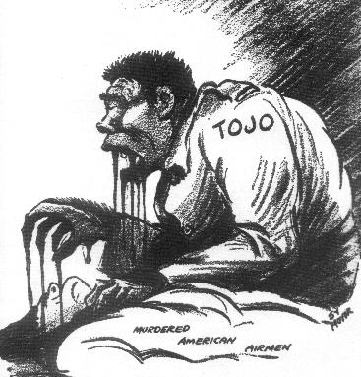
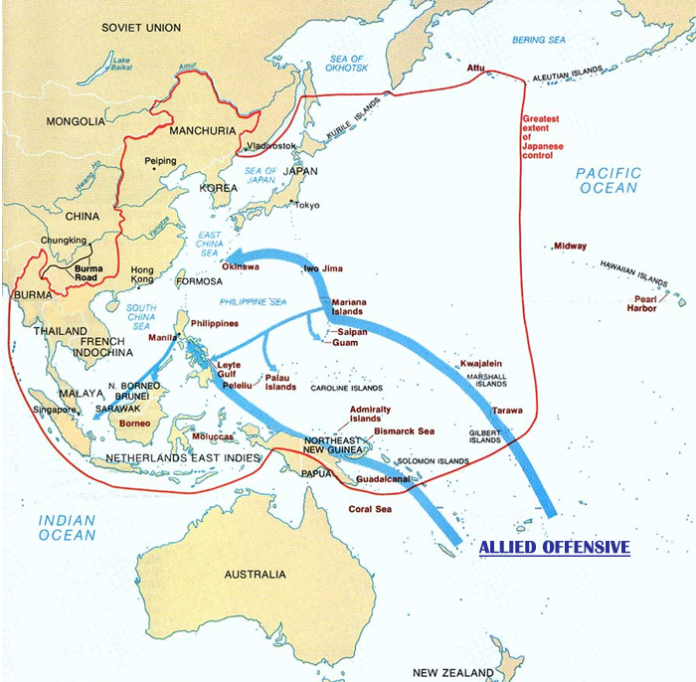
(The red line in this picture shows greatest extent of Japanese control.)

“Justice has nothing to do with victor nations and vanquished nations, but must be a moral standard that all the world's peoples can agree to. To seek this and to achieve it - that is true civilization.”
-Hideki Tojo

- The political cartoon was drawn as a result of President Roosevelt regarding Tojo’s executions on captured American airmen as “barbarous”. What does this suggest on Tojo’s militaristic policies?

- Does the cartoon serve as a representation of outside views on Tojo’s dictatorial rule?

- According to the map, Tojo gained a lot of control. If Tojo’s successes in militaristic events did not wane, would Japan have succeeded in further imperialism of East Asia?

- Is imperialism necessarily a trait of totalitarianism? Explain.

- Look at the political cartoon again and the quote on the third document? Why do you think it seems to contradict each other? What does this suggest about totalitarian views?

- According to the quote, Tojo seems to be concerned with civilization—an orderly function—and moral standard. How is this different or similar of other totalitarian leaders’ perspectives? Was this quote expected from a leader like Tojo?

Analyze the last set of documents to answer questions # 17-20.
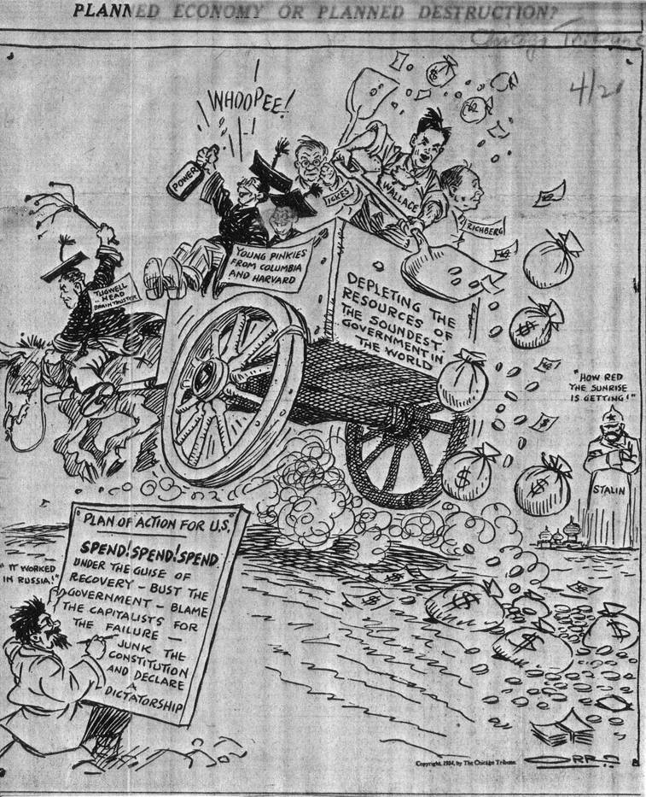
“During this period, Japan's peaceful commercial relations were successively obstructed, primarily by the American rupture of commercial relations, and this was a grave threat to the survival of Japan.”
-Hideki Tojo

- The political cartoon shows how the Americans got out of Depression thanks to World War II, including Hideki Tojo. What’s the irony of Tojo attacking Pearl Harbor because of economic strain from the United States?

- Is it safe to say that totalitarianism aid economies of other political systems?

- According to the quote, he regards again the “survival” of Japan. Do you think this is the main cause of Japan’s engagement to the war with the United States? Or could it be that Tojo wished to gain more power as a result?

- Here’s a thesis: totalitarianism is a depressant and a stimulant of economy. Explain why you agree or disagree with this statement.

