

Stress Relief

Cohort Readings

Consultant Evaluation

Progress Report

Overview

CS

Global Connections

COHORT SYSTEM





Cohort System Overview

As the student Proposal is accepted, each one is marked in one of the Cohort Groups listed at the bottom of this page. Each Cohort Group is working towards a similar base understanding, while going in depth on a particular focus.

The basic idea behind the Cohort System is to have like-minded people discussing like-minded projects. Although students are not limited to working with members of their cohort, the group is there as a support for others. There will be numerous occasions over the course of the seminar for Cohorts to work together. As the cohorts grow, new stakeholders will emerge, but essentially, the system is a group of peers made up of Tallwood seniors, Academy alumni, and mentors past and present.

CS1

For example, one student may propose to publish a series of articles on the Gaza Blockade. This student would be assigned to the Political / History Cohort, have a pool of mentors and advisors to work with and be sharing ideas and strategies for success with other members of the same cohort group. This will include peer evaluation, suggested readings, and research assistance. Each cohort will have a lead member to coordinate the actions of the group.

The distinction may not be so clear cut, however, and a student’s placement would not necessarily be matched entirely to what is being done to make the project successful. For example, a student designing t-shirts as a fundraiser for Operation Smile, while marketing and selling the t-shirts, could easily be placed in the Community Service/Fundraising cohort, the Fine Arts/ Design cohort, or the Marketing cohort.

These students will be placed on a case by case basis. The benefit to the student’s education will be a prime factor in deciding which cohort to place the student. So, for example, if the student above, has had years of design experience, but little to no marketing experience, that student will be placed in the Marketing Cohort so that he/she may be stretched.

The category of “other” exist because Cohort grouping is not limited to that below. It is a tool to free students to do their best, not a pair of fetters to lock students into place.

Political / History

Humanitarian / Fundraising

Public Relations /Marketing

Education / Awareness

The Environment/ Energy

Arts / Design

Science / Technology

Media / Events Planning

Languages / World Culture

Travel / Exchange Programmes

Ethics/ Belief Systems

Other

Sample Overview Sheet

(Submitted by Lead Member on a Monthly Basis)

Political / History Cohort

Mentor/Advisor Pool

Student name/number, mentor, affiliation, contact information)

Alumni

(full list of names, affiliations, Contact information)

Suggested Readings for Base Understandings

(include a running list of suggested readings from all members of cohort)

1.

2.

(Note: Overview Sheet does not go on wiki as it gives private contact information)

Special Features

(include description of any special features of the cohort – this could be means of communication, material placed on wiki, invitation to class, etc.)

Overview Sheet Compiled by:

(Name of Lead Member)

|  |
| --- |
| **SENIOR PROJECT PROGRESS REPORTS** |

* + - * For the best results give specific, accurate descriptions of tasks completed and work scheduled versus their personal experiences and feelings. Be sure to define terms used within the reports that might be unfamiliar.
      * **All project hours should be accounted for within your progress reports.**

|  |
| --- |
| **FORMAT –All progress reports are 12 pt. single-spaced with the exception of the reflective journal, which is double-spaced.**  **TO:** *Senior Project Grader*  **FROM:** *Your Name*  **DATE:** *Date reported typed*  CS2  **SUBJECT:** *Progress Report #: State the activity being worked on*  **PREVIOUS BACKGROUND:** *State any background information if necessary to aid in understanding the progress report (what you did last before this step).*  **TIME FRAME:** *Date began – date ending* **HOURS SPENT:** *Time spent during this time frame only – do not add up hours*  **WORK COMPLETED**   * *Discuss the items worked on or completed during this time frame.*   **WORK SCHEDULED**   * *Discuss what you plan on working on next.*   **PROBLEMS ENCOUNTERED**   * *What problems/difficulties did you encounter?* * *How did you handle them?*   **REFLECTIVE JOURNAL**   * *Journals should* ***be at least half a page.*** *Double-spaced.* |

**USE AS MUCH SPACE AS NECESSARY FOR EACH ENTRY**

|  |
| --- |
| **PROJECT CONSULTANT EVALUATION** |

Thank-you for taking the time to assist this student with the completion of their Senior Project. We hope it has been a positive experience for the student and for you. In order to better evaluate this student’s performance please take a few minutes to fill out the form below.

**Student’s Name _____________________________________________________**

**Project ______________________________________________________**

**Consultant’s Name______________________________________________________**

**Consultant’s Phone______________________________________________________**

Would you be interested in being a consultant again? Yes/No (please circle one)

May we have future students contact you for questions? Yes/No (please circle one)

**Please circle one** number for each are indicating the student’s level of achievement.

**Exceptional Satisfactory Low**

|  |  |  |  |
| --- | --- | --- | --- |
| CHALLENGE: Level of risk or difficulty for the student; student went beyond prior knowledge | 20-19-18-17 | 16-15-14 | CS3  13-12-__ |
| TIME COMMITMENT: Level of responsibility demonstrated; met intermediate deadlines, kept appointments, used time productively | 20-19-18-17 | 16-15-14 | 13-12-__ |
| PROBLEM SOLVING: Ability of student to overcome obstacles, persist when faced with difficulty, anticipate possible problems/solutions | 20-19-18-17 | 16-15-14 | 13-12-__ |
| USE OF RESOURCES: Student involved other people, organizations, books, web sites, etc. | 20-19-18-17 | 16-15-14 | 13-12-__ |
| CREATIVITY/QUALITY: Degree to which the product, performance or service demonstrates a concern for high quality. Does it represent the student’s best work? | 20-19-18-17 | 16-15-14 | 13-12-__ |
| **Please total points:** |  |  |  |

How many times have you met with the student during the course of the project?

3-4 5-7 7-10 10 or more

How many hours can you verify this student spent working on this project? ______

Please comment on any of the above areas of evaluation, or on anything you believe is relevant to this student’s performance on the Senior Project.

___________________________________________ DATE: ___________________

(Project Consultant Signature)

**Cohort Readings**

CS4

*Value: Is this a source worth keeping in the Cohort Readings as a contributor to the Cohort member’s base understanding of the general theme of the Cohort?*

*Missing evidence: What piece(s) of information or other sources would complete the intended message being represented by this source? What can you do to make this source, or any spin off research, useful to your own research and/or project?*

*Source Validity: Is this source valid? What outside sources support it, if any? What background knowledge or biases exist that would bring its validity into question?*

*Content: What is the basic theme and thesis of this Reading? What, if anything, is the author saying that is unique from the mainstream view or belief? What can you personally take away from the read- for your growth as a person? For your paper or project? What are the inferred messages sent by the content?*

*Answer the following about the reading as you set up your groups own virtual “Socratic Seminar” on the topic at hand. Use the Discussion tab and the prompts below on your Cohort Wikispace to create a conversation.*

*In 2010, senior Kellan Schmelz published a political article(found in the readings) on an e-zine specifically related to his research topic on the Gaza Strip blockade as a humanitarian crisis. Articles such as this one can easily qualify as Cohort material, in this case, for the Political/History Cohort. It is not essentially that there is universal agreement on the content of the articles; in fact, articles that invoke conversation is just as valid, if not more so, than pieces of writing that everyone agrees upon. Moreover, Suggested readings for Base Understanding does not need to be limited to pieces that are primers and overly explanatory. It may be simply a solid article that invites cohort members to dig deeper with some preliminary or even reactionary research.*

Peer Evaluation

PP

Suggested readings

Note on suggested readings on the wikis and the supplemental readings in the back of the manual..

Research assistance

Annotated bibliography / useful sites

Help Page

Lead member: wikispace managers, step one: clean out, step two: develop

Mentor / Advisor pool

List of Cohort members with contact

Professional demeanor. Any comments too personal in nature (including evaluations of an individual project) should not be posted. Always central will be the best interest of the project and education of the student, therefore, should there need to be more direct assistance, personal contact is suggested.

Understanding that there are different levels of technological proficiency and different means of communication (a face to face interview, skype, etc.) may be the preferred method of communication by some mentors. Students and mentors should discuss the best form of communication, and although encouraged to contribute to the wikispace, mentors are not required to use this as their contact with the group.

The development of the cohort system will be a regular task to all seniors, and be placed in the grade book; however, it should be seen as a tool.

Required Submissions to wikispaces

Research paper completed (for the perusal of the June 1st judges)

Paper abstract (for the perusal of the June 1st judges)

Project abstract (for the perusal of the June 1st judges)

Legacy assignments (for the future seniors)

Stress Relief

Senior Year (and this class) can be stressful, so part of the process for you individually is to find ways to reduce that stress level. Suggestions on how to do this are given by Judy Galbraith, M.A. and Jim Delisle, Ph.D in The Gifted Kids’ Survival Guide, p. 131 (1996)

Eight Stress Reduction Tips

1. Think back to other times when you have successfully coped with a difficult situation, person, or event. What did you say? What did you do? You may be able to recycle those winning strategies.
2. Learn how to handle stress without alienating the people around you. Don’t take it out on your family, friends or teachers, even if you (erroneously) believe that they “caused” your stress.
3. Find a sounding board—someone who will listen and, if you want, offer honest, respectful, and trustworthy advice.
4. If you don’t know how to relax learn how.* Maintaining our physical and mental health requires that we spend at least part of each day slowing down.
5. Develop and maintain your sense of humor. Many gifted people have a tendency to focus on the serious side of life. Laughter is a terrific stress reducer.
6. Compile a “library” of stress reduction techniques. If one doesn’t work for a particular situation, you can always try another.
7. Don’t give up. Handling stress is a learned skill and an ongoing endeavor. Few of us are taught it in school; either we learn it on our own, or we find “teachers” at various junctures in our lives.
8. Always remember that you don’t have to go it alone. Even in your darkest, most stressful hour, there’s bound to be someone or somewhere you can turn to for help. Suggestions:

-A supportive adult -a friendly neighbor

-your favorite friend -a teen clinic

-an emergency hotline -the public library

-a stress management class -a counselor

-a crisis intervention center

Other stress reduction authors for teens

(Galbraith and Delisle recommended)

Stress Management

Eleanor H. Ayer, Adolph Moser.

Time Management

Edwin C. Bliss, Alan Lakein.

Perfectionism

Miriam Adderholdt-Elliott

Making Mistakes

Charlotte F. Jones, Royston M. Roberts

Goal setting

Andrew J. DuBrin, Patricia Kramer

Assertiveness

Robert E. Alberti and Michael L. Emmons

Procrastination

*The book goes on to suggest two tried and true ways to really relax as advocated by speaker and author Earl Hipp, namely deep breathing and meditation. (pp. 132-136).

CS5

I understand procrastination; I really do. I think many misinterpret it for laziness. Sometimes it stems from lack of understanding of the task at hand; sometimes it emerges from an overwhelming feeling; sometimes it creeps out because we don’t like what we are about to do (or more than likely, we don’t perceive that we like what we are about to do). All procrastination situations can be seen as a hopeful situation. Anyone who regularly practices procrastination hopes the situation will go away.

It then becomes what historians call a war of attrition…who can hold out longer? The problem really isn’t in doing or not doing; it is rather about thinking about doing or not thinking about doing. You see, thinking about doing, involves thinking about the steps to doing…and I think this is really the heart of the problem. Students who just want to get it done with do not want to think about the steps. This means that:

1) they are not invested in the task

2) they don’t really understand the task

3) they don’t really have the tools to accomplish the task

4) any perception of the above 3 points.

So to conquer Procrastination before it conquers you, make sure you are invested, you understand the task, and you have the tools or skills to accomplish it (or at least the knowledge on how to obtain these tools).

One way to conquer Procrastination is to Chunk the material. Don’t work on it all at once. Separate into manageable bites. After all, who eats a whole cow when going to McDonald’s? Remember that any big project (in life as well as in class) is just a bunch of small projects clumped together. When you chunk material, set a small goal to accomplish, then reward yourself with a small reward. “Once I complete one page, I will be able to play with my Barometer Man for 10 minutes…”

Also allow yourself for occasional breaks, but be sure to limit them. Certainly, you need to know your particular mood at a particular time (a barometer of sorts), so that you can work when working is best, and take breaks when you energy is low. The break, however, can be more time consuming than actual project. If this happens, it’s no longer a break, but avoidance and procrastination. Recognize it for what it is. Read this handout [www.unc.edu/depts/wcweb/handouts/procrastination.html](http://www.unc.edu/depts/wcweb/handouts/procrastination.html), and then read my entire book on the topic (unpublished) below:

Procrastination

By E. DeMott

FIN

Chunking Material “Drag Drawers”

PRESENTATION

PROJECT

PAPER

PROPOSAL

PORTFOLIO

THINGS TO DO LISTS ARE A GREAT EXAMPLE OF CHUNKING.

BUT BEWARE, SOMETIMES, THEY TOO CAN LOOK CUMBERSOME AND OVERWHELMING.

MAYBE THE PROBLEM IS THAT YOU ARE LOOKING AT THEM ALL AT ONCE….MAYBE YOUR SEEING TOO MUCH AND THAT IS GIVING YOU PAUSE.

SO GROUP YOUR TASKS INTO CATEGORIES IN THE BOXES UNDERNEATH THE CENTRAL BOX.

THEN WRITE A THINGS TO DO LIST FOR EACH ONE, AND PUSH THE DRAWER “IN” SO THAT YOU DON’T NEED TO STARE AT IT.

WRITE A “THINGS I’LL DO TODAY LIST” IN THE CENTER BOX. WHEN FINISHED, CROSS THE ITEM OFF OF BOTH LISTS.

COHORT

Barometer: Knowing Your Mood

Gauge your understanding, mood, completion of the requirements.

Communicate your barometer to those who are assisting you by using this page.

You may drag items to the figure in the middle of the page, or change the background (or make your own using Insert function).

Hair Styles / Space Helmets

Let us know what you are thinking…







Accessories

Yield

WHOA!

We the People of the United States …

BEANZ

Notes on Technical Features of page: There are overlapped text boxes or shapes used on this page. Simply use the “Order” function on the textbox to “Send Backward” or “Bring Forward”

Advice from North America’s Top Speakers for Youth

Patty Hendrickson, professional motivational speaker, relates a story about the stress of receiving a paper back during her master’s program. The stress was high because any test grade lower than a B would result in the student being removed from the program (Chester 112).

At the start of the next class my professor returned our tests. I was smiling from ear to ear waiting for m good grade. When I looked down my expression turned from jubilation to utter terror. The whole first page of the exam was a sea of red marks, checks and circles. I looked through the entire exam. Yikes! There were only three places where I didn’t have an ugly red mark. Immediately my abusive mental critic… started having a field day. *You idiot! Don’t cry. What a twit! I can’t believe you screwed up so bad. Just sit her, you dork. Don’t cry. You blew it! You are getting kicked out of here. LOSER!* (Chester, 112).

Hendrickson went on to explain that the professor Congratulated them after giving them their papers back. He played with convention and announced that he marked in red all of the correct answers, explaining that students “know what (they) don’t do well” and his method brought “attention to what (they) do well.” (Chester, 112-113).

This advice, Focusing on the Good Stuff, is followed by the need to understand yourself and your space, as well as building momentum through taking action (Chester 111-115). More suggestions on maintaining a positive outlook can be found on Hendrickson’s website ([www.pattyhendrickson.com](http://www.pattyhendrickson.com) or she can be reached personally –via email- at [Patty@PattyHendrickson.com](mailto:Patty@PattyHendrickson.com))

Mark Bernstein, who according to editor Eric Chester, plays music, writes, and a big “Jimmy” fan (Chester 77). He is a regular motivational speaker who started his quest to find meaning in life immediately after the September 11th attacks, upon finding his best friend was pregnant. He wondered about the unborn child, contemplated what kind of world this child would grow up in, and decided that it was up to him. He writes about this in the chapter entitled “Kindness: The Ultimate Selfish Act?” (Chester, 69-77)

The article finishes off with a challenge for you to do three acts of kindness, and he specifies that they cannot be run of the mill acts. They must be “unique, fun, and creative” such as stated in his advice: “Don’t just buy your mom flowers – plant her a tree” (Chester 76). Finally his challenge finishes with a call for emails. Once you’ve done three acts of kindness, send him an email at [mark@markberstein.com](mailto:mark@markberstein.com) (web: [www.markberstein.com](http://www.markberstein.com)) so that you can “brag about yourself, (and) share…the joy you spread”(Chester 76). Hopefully this will help you discover purpose in the day to day life we all lead.

These, and other stories, come from “Go M.A.D.: Make a Difference: Real Stuff Real Teens Can Do to Make a Real Difference … in an Unreal World”, edited by Eric Chester from Generation Why, Inc. ([eric@ericchester.com](mailto:eric@ericchester.com), web: [www.ericchester.com](http://www.ericchester.com) )

Focus Activity

Combining Themes:

[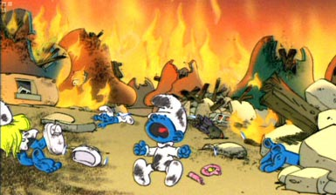](http://go2.wordpress.com/?id=725X1342&site=gerrycanavan.wordpress.com&url=http://djmonstermo.blogspot.com/2005/10/unicef-bombs-smurfs.html&sref=http://gerrycanavan.wordpress.com/2005/10/11/the-smurf-to-end-all-smurfs/)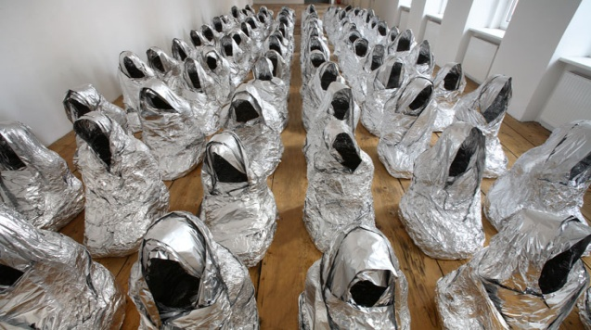

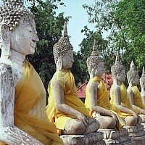 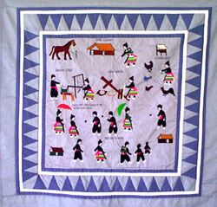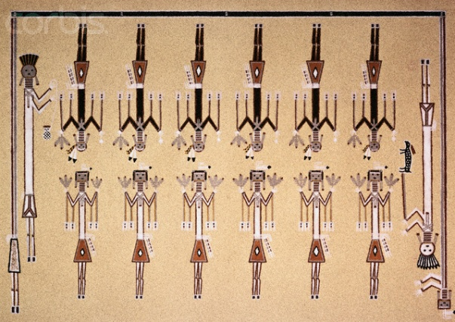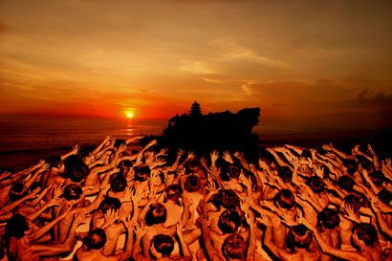

How are themes combined in the visual representations here?

How does having more than one deepen the interests level? The meaning?

How is nuanced meaning a worthwhile goal?

Insert your own picture here

<http://gerrycanavan.wordpress.com/2005/10/11/the-smurf-to-end-all-smurfs/>

<http://www.saatchi-gallery.co.uk/>

<http://familyhealthandwellness.org/reiki_history.html>

<http://www.uwec.edu/newsreleases/06/april/0404HmongStudies.htm>

<http://www.kmandiri.com/?go=bali-culture.php>

<http://www.corbisimages.com/Enlargement/IE001446.html>