.



Organization

Techniques

More Punch

Rubric & Review

Editing & Proofreading

On Writing & Prewriting

WR

Global Connections

writing





WR1

PP

Writing Practice

In the space below take notes on the discussion regarding the views of both Bradbury (Zen and the Art of Writing) and King (On Writing) as well as two other authors brought into class by the students. Create your impression of the Writing Process in a paragraph called “My View” at the bottom of the following page.

Bradbury: Zen and the Art of Writing

King: On Writing

Author Three:

Author Four:

My View:

Heuristics

So you have writer’s block… why not try a few techniques from York University to get Writer’s Unblock. <http://www.yorku.ca/tutorial/prewriting/introduction.html>

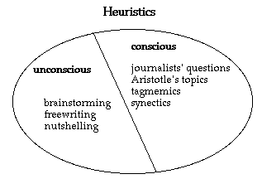

Describe the three Unconscious strategies.

Prewriting Sites

There are more great Prewriting sites.

*Always write drunk and edit sober*

Browse through these and come up with 5 tactics that would really work for you. Try one of them on the following page.

Most of these sites are casual and some cover much more than prewriting, but please feel free to dig around.

(you’ve already read this first one in the “Procrastination” page, but in case you didn’t get around to it…here it is again: <http://www.unc.edu/depts/wcweb/handouts/procrastination.html>)

Well you’re browsing, try to find the source of the quote above from these sites:

<http://www.nvcc.edu/home/vkryston/HTML/Information/Writing/Prewriting/Prewriting.html>

<http://www.successful-blog.com/1/bad-boys-of-writing-just-write-and-it-will-be-spectacular/>

<http://www.sffworld.com/mul/115p0.html>

<http://www.poewar.com/getting-ready-to-write-rituals-vs-distractions/>

<http://webclass.lakeland.cc.il.us/sphillips/eng121/lesson2_prewriting_techniques.html>

<http://www.redroom.com/blog/devorah-major/writing-and-procrastination-rituals>

<http://grammar.ccc.commnet.edu/grammar/composition/brainstorm_block.htm>

<http://www.43folders.com/2004/11/18/hack-your-way-out-of-writers-block>

<http://leo.stcloudstate.edu/acadwrite/block.html>

<http://www.transaction.net/web/tutor/text/dissolve.html>

Your 5 tactics:

Your very special Prewriting page

.

List 5 ideas that emerged from this form of brainstorming

1.

2.

3.

4.

5.

Students 1 and 2

1. Present your topic idea to Students 3 and 4
2. Break up into subgroup and with partner Student, use Inspiration (or other Graphic Organizer program) to brainstorm ideas about topic idea of Students 3 and 4 (Note: Students should not confer with the subgroup they are brainstorming for.
3. Present graphically organized brainstorm to the Students 3 and 4

Students 3 and 4

Follow the instructions above, except for Students 1 and 2

WR2

Select the idea(s) that will be the most:

Practical to accomplish

Ambitious to accomplish

Enjoyable to accomplish

______________________________ to accomplish

List 5 spin off ideas from the student suggestions

1.

2.

3.

4.

5.

*Group Brainstorming*



This page is brought to you by the OWL at Purdue (http://owl.english.purdue.edu/). When printing this page, you must include the entire legal notice at bottom.

### Outlines

There are numerous options for outlining, and no doubt students will be familiar with the sample outlines covered on the next couple of pages. These are common types used for specific fields of study. The first is often used for the humanities, Social Science and business writing. The second is connected with scientific and technical writing.

There are other options that may be equally useful to you as you plan your work, however as is explained by Perdue OWL.

### *Full Sentence Outlines*

*The full sentence outline format is essentially the same as the Alphanumeric outline. The main difference (as the title suggests) is that full sentences are required at each level of the outline. This outline is most often used when preparing a traditional essay..*

### *Decimal Outlines*

*The decimal outline is similar in format to the alphanumeric outline. The added benefit is a system of decimal notation that clearly shows how every level of the outline relates to the larger whole.*

Perdue OWL goes on to explain that there are four main purposes for an outline, namely:

Parallelism

Coordination

Subordination

Division

Perdue OWL suggest four very simple steps in how to create an outline:

* ***Brainstorm****: List all the ideas that you want to include in your paper.*

**Spend some time perusing the site. What areas of the website do you find useful for assisting you with your work in Global Connections class? In other courses?**

To complete the notes above review the website <http://owl.english.purdue.edu/owl/resource/544/01/>

Sample Outline

(Humanities, Social Science, and Business Writing)

Answer:

How could this particular outline be improved when translating it to a paper?

I. Introduction

A. What is Lifestraw?

B. Why are countries suffering from bad water

II. Body

A. Lifestraw is an NGO helping those who need clean water get clean water.

B. Latin America

1. Columbia

a. Statistics

b. Reasons why it is suffering from bad water

c. Personal stories

2. Africa

a. South Africa

b. Western Africa

(1) Infrastructural problems in Nigeria

(2) Infrastructural problems in Mali

(a) Poverty

(b) Environment

III. Conclusion

Sample Outline

(Technical and Scientific Writing)

Answer:

How could this particular outline be improved when translating it to a paper?

1. Introduction

1.1 Classification of Sustainable Housing Needs around the world

1.2 Classification of Sustainable Housing Options around the world

2. Sustainable Housing Situation in Ghana

2.1Background information on Ghana housing (historical/cultural)

2.2 Allocation of Materials

2.2.1Indigenous materials

2.2.2 Imported materials

2.2.2.1Cost of building using imported materials

2.2.2.2Environmental impact of using imported materials

2.3Cultural issues regarding building internationally built sustainable

housing in Ghana

3. Conclusion, Analysis and recommendations

Answering your Overarching Question

Answers should be able to answer guiding questions to in turn answer the overarching question.

Step ONE: Consider your Overarching Question (This will ultimately be answered by your thesis statement in the introduction. However, due to the depth of this paper, each section can have a separate thesis that adds onto or supports the overarching thesis. Students can think of it in military terms in that the Overarching Question and Thesis are the Generals, and each section is an Officer equal to each other but ranked lower than the General. They operate their paragraphs with their commanding presence, but they also must follow the orders and the mission of the Generals. Any rogue paragraphs or sections do not belong in a well ordered military and must be cut off, despite the skill and talent of the Officers. Otherwise, they have their own mission and do not contribute to the success of the General’s mission.)

Our example: Why do nations go to war?

Step TWO: Come up with your Essential Understandings. What is it that you think is the answer to the Overarching Question. (Adapted from *Concept-Based Curriculum and Instruction for the Thinking Classroom* by H. Lynn Erickson, 2007, p. 163-165)

* 1. Nations may form alliances to further political and/or economic self-interests.
  2. Political revolutions are fought to gain freedoms from, or changes in, the controlling government.
  3. Democratic governments seek public support and use compromise to settle national policy debates.
  4. War can stimulate, depress, or decimate the economy of a region or nation.
  5. Revolutions can change social, economic, and political relationships in a country.
  6. Cultural conflicts can lead to discrimination and prejudice.
  7. Countries carry out political, military, and economic expansions to increase wealth, power, and prestige.
  8. The desire of countries to satisfy their needs and wants can cause social and political conflicts.
  9. Countries may control colonies for economic benefit.
  10. Subversive groups can resist a foreign influence.
  11. Geography affects the way people satisfy their needs and wants.
  12. Geography can establish the way a war is fought.

Step THREE: Fill in your WHY, WHO, WHAT, WHERE, WHEN, HOW, SO WHAT Circles, giving as much detail as you can muster.

Our examples: See sheet with circles.

Step FOUR: Create Guiding Questions evoked from the examples in the circles.

* 1. What were some similarities and differences in the three wars I used as examples? (WWI, Latin America War for Independence, Punic Wars)
  2. Why was the Alliance System such a prevalent cause for WWI, but not for the other wars? Is this a unique phenomenon or is it a matter of coverage of this issue?
  3. To what extent does colonialism tie these three wars together?
  4. What mindset needs to exist for a nation to turn to war?
  5. Does location alter the nature of war? What about the rationale for war?
  6. Do the time periods alter the nature of the answer? If so, how and why?
  7. Why does the method of warfare change, but not the rationale?

Step FIVE: Answer the question: Are the preconceived statements in Step TWO true or relevant to the time periods being discussed? If yes, they are valid examples; if no, then why not. Does this disprove the statement?

Step SIX: Salvage what is useable. Organize any useable material in Step FOUR into sections and subsections, remembering always who is the General and who are the Officers. What are some of the Section thesis statements? Do you need to alter some of your preconceived statements for cohesiveness?

Step SEVEN: Answer the Overarching Question to create an Overarching Thesis.

Step EIGHT: Use this structure and organization to assist you in analyzing your research as your write your paper.

Concept Based Organizer

(Adapted from *Concept-Based Curriculum and Instruction for the Thinking Classroom* by H. Lynn Erickson, 2007, p. 140, 141)

THE CENTRAL QUESTIONS



THE CENTRAL QUESTIONS

Circle one:WHY? (Broad Question)

*Why do nations go to war?*

Circle 2:WHO? (Examples from

2-3 different historical periods)

*WWI, Latin American War of Independence, Punic Wars*

Circle 3:WHAT? (Issues, Events)

*WWI Alliance system, byproduct of Colonialist mindset, Social Darwinism; Latin American War of Independence: historical examples in U.S., classism, Monroe Doctrine; Punic Wars: control and power, empire building through conquest, good ol’ fashion revenge.*

Circle 4:WHERE? (Location)

*Europe and colonies, Latin America; Mediterranean world*

Circle 5:WHEN?(Dates, Periods)

*1914-1918; early-mid 19th century; ancient times*

Circle 6:HOW? (Methods)

*Trench warfare, U-boat, birth of air attacks; Land warfare, freeing of slaves for military service; land and naval, salting of the earth*

Circle 7:SO WHAT? (Results, Consequences, Your Opinion. This is your analysis and therefore the “most important circle- as long as it is based upon the information contained in the other circles.)

Step ONE Consider

Step TWO Come up with

Step THREE Fill in

Step FOUR Create

Step FIVE: Answer

Step SIX: Salvage

Step SEVEN: Answer

Step EIGHT: Use

THE CENTRAL QUESTIONS



Grouping

There are numerous ways to group your thoughts. Using your own research and writing as your guide, explain each grouping in the area next to each term. Then choose three from the list to organize your thoughts. Two boxes are left blank so that you may add your own customized techniques.

|  |  |
| --- | --- |
| 1 | 9 |
| 2 | 10 |
| 3 | 11 |
| 4 | 12 |
| 5 | 13 |
| 6 | 14 |
| 7 | 15 |
| 8 | 16 |

Focus Activity

With this topic of the science of natural disasters, and the human impact on natural disasters, place the following in order, and then answer the question, how would you use bridges to tie these items together?

A bridge is like an extended transition that is created by you and is at least a paragraph in length. It uses elements from the prior paragraph and the following paragraph and links them together through analysis.

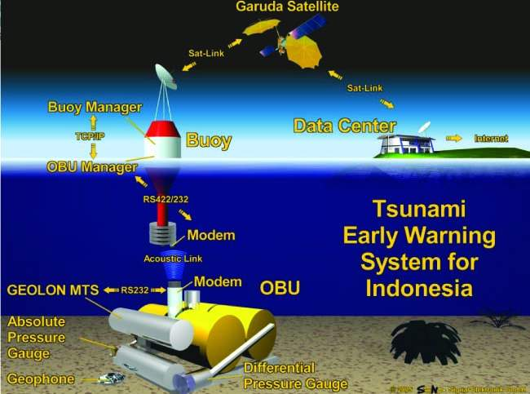 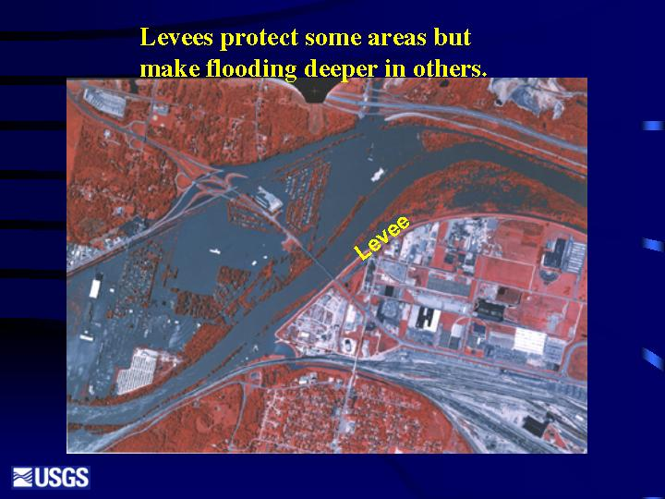 [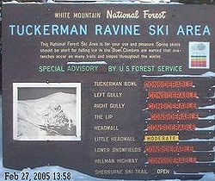](http://en.wikipedia.org/wiki/File:Avalanche_warning_in_Tuckerman.JPG) 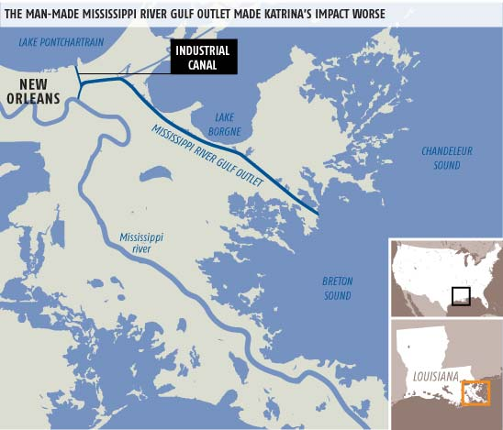 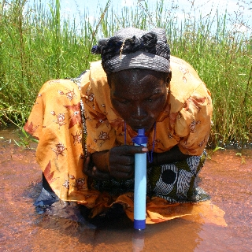 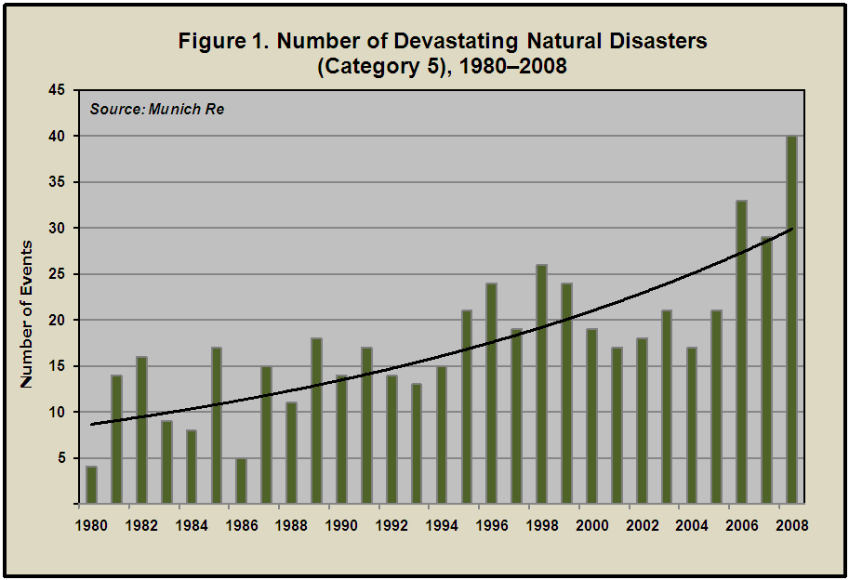 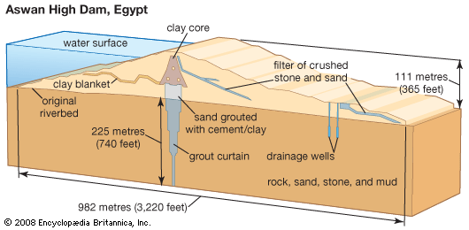 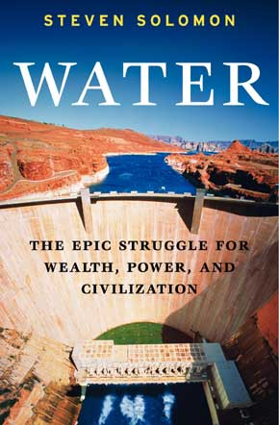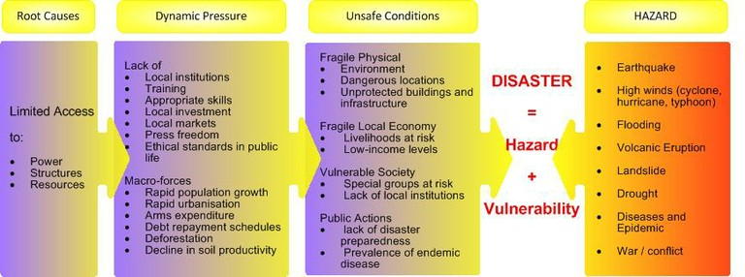<http://www.newscientist.com/article/mg18825244.000-ship-canal-was-storm-funnel-during-katrina.html>

<http://vulpeslibris.wordpress.com/?archives-list=1>

<http://makewealthhistory.org/2010/03/01/climate-change-and-natural-disasters>

[www.kum-kiel.de/Aktuelles_eng.htm](http://www.kum-kiel.de/Aktuelles_eng.htm)

[www.ks.water.usgs.gov/pubs/presentations/flood.1951.html](http://www.ks.water.usgs.gov/pubs/presentations/flood.1951.html)

<http://en.wikipedia.org/wiki/Avalanche>

[www.log.logcluster.org/preparedness/intervention-types/index.html](http://www.log.logcluster.org/preparedness/intervention-types/index.html)

<http://peoplesdesignaward.cooperhewitt.org/2007/nominee/1043>

<http://www.britannica.com/EBchecked/topic-art/150337/110359/Aswan-High-Dam-Egypt>

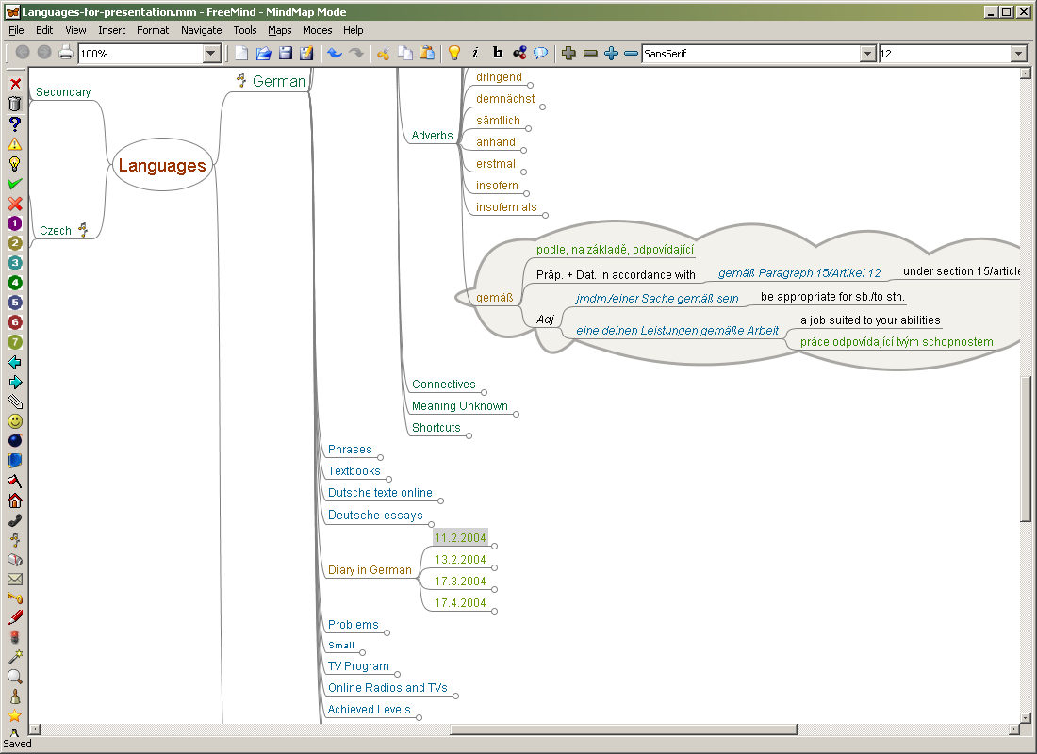

There are numerous visual or graphic organizers, such as Inspiration, Timeliner, Xcel, or templates used in Word documents. Use Your Very Special Graphic Organizer Sheet to organize one section of your paper using the SmartArt icon, or any graphic organizer that you have not presently mastered. This manual employs many examples of SmartArt, Tables, Bookmarking, textboxes, etc. as well as suggestions on use on the internet or technology, including wikispaces, webpaging, videoconferencing, presentation makers (PowerPoint, prezi, etc). The idea is for you to stretch yourself. So here is your drawing board. Go to it. Be sure to be ready to explain why this is a stretch for you.

Students may wish to look for more challenging ways to use graphic organizers (perhaps they’ve mastered the tools offered on their word processor. This may result in the need to download programs such as the example in this screenshot of learning German in a mind mapping program.

[*http://freemind.sourceforge.net/FreeMind-learning-german.png*](http://freemind.sourceforge.net/FreeMind-learning-german.png)

Many great sources can be used to find the best graphic organizers, but what is really important is finding one that works for you. The Venn Diagram, for example, is now a standard in every history classroom. Many more are discussed in *Classroom Instruction that Works* (Marzano, Pickering, and Pollock),2001, pp. 72-83 in a chapter entitled “Nonlinguistic Representations.” Other suggestions include David Hyerle’s *Visual Tools for Constructing Knowledge* (1996) as well as research and/or theories put forth by J.R. Anderson (1990), Robinson & Kiewra (1996), Welch (1997) Paivio (1969, 1971, and 1990), Richardson (1983), Macklin (1997), Druyan (1997), Gerlic & Jausovec (1999), and others.

Your Very Special Graphic Organizer Sheet

Iceberg Model

Use the Iceberg Model to ensure depth in your writing. You may wish to use multiple icebergs throughout your written work. For example, a method of organizing may very well be the general to in depth model that the Iceberg model provides. Each section and subsection could easily repeat this template. Once worked out here, integrate these structural ideas into your paper. (From *It’s all Connected* published by Facing the Future)

Adding Punch!

-Add Nominative Clauses rather than the standard stand alone definition.

-Reducing the use of passive voice (review your be verbs and extract them!)

-List your thoughts on an issue using 25 adjectives. Insert them into your text.

-Use more metaphoric language and/or an extended metaphor that would act as a cohesive element to the section or even to the paper as a whole.

-Slip in a foreign word or phrase if appropriate (Latin is always a good pick). Beware though, not all languages are equal in usability. Refer to the confines of your paper (e.g. <http://www.movies-dictionary.org/English-to-Vulcan-Dictionary> would not offer useful words or phrases!)

-Try out new words, but be cautious, be sure the words are appropriate in meaning, context, and style. Use the thesaurus wisely rather than wildly.

WR3

-Log new words in a journal. Sites such as [www.dictionary.com](http://www.dictionary.com) have “words of the day”. You’ll be surprised. These words will pop up in regular usage.

-Use new forms of the words you already know (e.g. the adjective form rather than the noun form). Look for similar words that can relay the same meaning.

-Avoid at all cost the dictionary introduction… (“According to X dictionary, the word *Foudroyant* means…” or “From information I gathered from X, dictionary, *Heloise* is the…” or any other similar form.)

“Write” a wordless book for your research. Like in children’s books such as David Wiesner’s *Floatsom*, the pictures tell the story (and words aren’t allowed). This should assist you in “seeing” the project and having to explain it. A more “adult” version of this is called photojournalism or storyboarding.* Rowan Atkinson (Mr. Bean) discusses the need for a strong visual element when making his Mr. Bean productions. Anyone who’s seen them knows that there are long stretches without words and only pictures tell the story . Watch <http://www.youtube.com/watch?v=RyDY0hiMZy8> to see what I mean.

Follow the techniques for word acquisition that is utilized in Levitt, Burger, Guralnick’s books called the Weighty Word Book or the Weighty Word Book Two (both children’s books), but employing great mnemonic devices.

(I double dog dare you to check out the children’s books from the library).*

Pick two strategies you’ll stick through during the research/writing process. Pick five sentences to fix using the following format:

Original Sentence Alteration

*Suggestions based upon Ms. Anita Parker’s presentation “Supporting and Guiding Precocious Readers”, August 21, 2010

Now let’s look at the Punches to the Body

|  |  |  |
| --- | --- | --- |
| Section | Technique | Sample |
|  |  |  |
|  |  |  |
|  |  |  |
|  |  |  |

The Conclusive Punch: You!

In the conclusion, with the fight going on for way too many rounds, all you have left is you. You’ve used the fancy footwork in the opener, you’ve perfected the expert, well laid out punches of the body through months of training and toil. But now, when you are gasping for breath and you are on the ropes, when the final bell is about to ring, something deep inside is calling out, Get Up! Fight! Don’t Surrender!

The conclusion, it has been falsely said, is just a repetition of the introduction put in different words. If this were so, all films should end where they began, all life stories would return to the place of origin, all change and advancement would be, in short, obsolete and meaningless.

The conclusion in writing is no different. It is, as is true in all these other forms, the reason for writing the paper in the first place. It is the transformative change that takes place from the process of researching and writing; it is the new contribution to humanity and the pool of existing knowledge; it is admittance of struggle if need be, and celebration of overcoming obstacles. It is the Rocky Balboa story – who, incidentally, lost in his first bout, but changed through the process to an iconic figure who brought meaning and honor to the word *struggle*. Sometimes we fall, so that we can learn how to get up.

In your conclusion, what is your new understanding? Your contribution? Your pitfalls and victories? Write them in the box below, without concern for form or shape. You’ll edit it later.

Conclusion’s Knock Out Punch: The Answer!

It is ironic that Rocky, like us all perhaps, punches outward to find inner truth. The writing’s question is to be answered in the conclusion. But since the question is “Unanswerable”, sometimes questions begat questions (sometimes there’s a need for a sequel – or five sequels, as in the case of Rocky). If there is an answer that comes without struggle, maybe it’s time to change the question. If there is an answer with a struggle, then there is something unique. If there is a struggle without an answer, it is time to state this here.

Ask yourself the following questions as you approach your conclusion.

* 1. What does it all mean?
  2. So what? (What significance does it have?)
  3. Is it logical?

# How about adding a Punch to your intro?

Remember the Order, Body-Conclusion-Intro (This is the order you’ll write your paper)

# Attention Grabber:

# Anecdote:

# Dialogue:

# Summary Sentence:

Philosophical Truth:

Shocking Statistic:

Quotation:

Writing Great Thesis Statements

In the box below, summarize the contents of the section on Thesis statements from the two sources listed below. Use your own words or give proper quotations/ citations when the word or phrase is not yours. <http://www.scribendi.com/advice/thesis_statement.en.html>

<http://www.campusgrotto.com/how-to-write-a-great-thesis-statement.html>

The SOCACA* TEST for Great Thesis Statements:

|  |  |
| --- | --- |
| Thesis: |  |
| S |  |
| O |  |
| C |  |
| A |  |
| C |  |
| A |  |

*Supportable, Opinionated, Clear, Analytical, Comprehensive, Arguable

Trainwrecking* and Aftermath Cleanup

*Quinn loved the movies and went religiously to the Saturday matinee from when he was a young boy.*

*Among Quinn’s favorite weekend films were the ones of adventure. On some weekends, he would stay in the cinema to watch a second showing of the same film.*

Attempt your own train wreck (and cleanup) right here.

Trainwrecking: join the two paragraphs with similar words repeating in the last sentence of the former paragraph and the first sentence of the latter.

*Quinn loved the movies and on weekends religiously went to the Saturday matinee from when he was a young boy.*

*Among young Quinn’s favorite Saturday matinee films were ones of adventure.*

Now you have repeated phrases…yuck, what a trainwreck! But do an aftermath cleanup.

WR4

The cleanup allows for concepts to drift from one paragraph to the next and adds more specific details without looking (or sounding) like a trainwreck.

*As a young boy, Quinn loved the movies, going religiously to adventure films often featured at the Saturday matinee, at times even staying in the cinema to watch a second showing of the same film.*

**\*trainwrecking** - DJ lingo for one of a DJ's worst nightmares, when two songs are mixed together but don't match up.

[www.urbandictionary.com](http://www.urbandictionary.com)Using Words of Transition

Integrate one example from each category into your paper.

<http://www.studygs.net/wrtstr6.htm>

***Pick three First Sentences of paragraphs or sections and revise them by inserting appropriate transitions***

Sentence 3

Sentence 2

Sentence 1

|  |  |  |
| --- | --- | --- |
| |  | | --- | | **Using Transitional Words and Phrases**  **A coherent paper** allows the reader to flow from the first supporting point to the last.  **Transitions indicate relations**, whether within a sentence, paragraph, or paper. This list illustrates "relationships" between ideas, followed by words and phrases that can connect them. | | ***Addition:*** *also, again, as well as, besides, coupled with, furthermore, in addition,*  *likewise, moreover, similarly*  ***Consequence:*** *accordingly, as a result, consequently, for this reason, for this purpose,  hence, otherwise, so then, subsequently, therefore, thus, thereupon, wherefore*  ***Generalizing:*** *as a rule, as usual, for the most part, generally, generally speaking, ordinarily, usually*  ***Exemplifying:*** *chiefly, especially, for instance, in particular, markedly, namely,  particularly,  including, specifically, such as*  ***Illustration:*** *for example, for instance, for one thing, as an illustration,  illustrated with, as an example, in this case*  ***Emphasis*** *above all, chiefly, with attention to, especially, particularly, singularly*  ***Similarity:*** *comparatively, coupled with, correspondingly, identically, likewise, similar,*  *moreover, together with*  ***Exception:***[*aside from*](http://thesaurus.reference.com/browse/aside%20from)*,* [*barring*](http://thesaurus.reference.com/browse/barring)*,* [*beside*](http://thesaurus.reference.com/browse/beside)*s,* [*except*](http://thesaurus.reference.com/browse/except)*,* [*excepting*](http://thesaurus.reference.com/browse/excepting)*,* [*excluding*](http://thesaurus.reference.com/browse/excluding)*,* [*exclusive of*](http://thesaurus.reference.com/browse/exclusive%20of)*,*  [*other than*](http://thesaurus.reference.com/browse/other%20than)*,* [*outside of*](http://thesaurus.reference.com/browse/outside%20of)*,* [*save*](http://thesaurus.reference.com/browse/save)  ***Restatement:*** *in essence, in other words, namely, that is, that is to say,  in short, in brief, to put it differently*  ***Contrast and Comparison:***  *contrast, by the same token, conversely, instead, likewise, on one hand, on the other hand, on the contrary, rather, similarly, yet, but, however, still, nevertheless, in contrast*  ***Sequence:*** *at first, first of all, to begin with, in the first place, at the same time, for now, for the time being, the next step, in time, in turn, later on, meanwhile, next, then, soon, the meantime, later, while, earlier, simultaneously, afterward, in conclusion, with this in mind,*  ***Summarizing:*** *after all, all in all, all things considered, briefly, by and large, in any case, in any event,  in brief, in conclusion, on the whole, in short, in summary, in the final analysis,  in the long run, on balance, to sum up, to summarize, finally*  ***Diversion:*** *by the way, incidentally*  ***Direction:*** *here, there, over there, beyond, nearly, opposite, under, above, to the left, to the right, in the distance*  As exciting (and wholesome) as it is to have a “big doll family,” wouldn’t a few transitions spice up the lives of our young protagonists, Dick and Jane?  In the box provided below, feel free to rework the phrasing, using some of the transitional words and phrases in the list above. Some sentences might need restructuring.  Do you want to have your writing sound like this? If so, avoid transitional words and phrases at all cost!  Images source: *Fun with Dick and Jane: A Commemorative Collection of Stories.* San Francisco: Collins Publishers, 1996.  <http://faculty.valpo.edu/bflak/dickjane/spot.html>  <http://faculty.valpo.edu/bflak/dickjane/dolls.html> |   http://faculty.valpo.edu/bflak/dickjane/spot.jpg  http://faculty.valpo.edu/bflak/dickjane/dolls.jpg |

Integrating Quotations

From <http://www2.ivcc.edu/rambo/eng1001/quotes.htm>

* 1. Take the Using Quotations Quiz below (you need to take quiz Online) Give Score here:_____________
  2. Read the “Integrating Quotations into sentences” article found on the website above and write quotations into your paragraphs, trying to get a minimum of one per every couple of paragraphs. Use all four ways to integrate quotations in your writing, varying them from one use to the next. Use the rest of your page to plan where and how you will use quotes.

|  |  |
| --- | --- |
| Original Sentence | New and Improved Quote-rich sentence |
|  |  |
|  |  |
|  |  |

# Editing and Proofreading

The following is a Cloze Note activity. To complete the blanks, you’ll need to read through the article on Editing and Proofreading. (<http://www.unc.edu/depts/wcweb/handouts/proofread.html>)

Some areas are direct quotations, others are summaries. So that your brain is “in the game,” I would like you to type out the words, or paraphrase, rather than cutting and pasting into the blanks.

## What this handout is about

This handout provides some __________and strategies for ____________ your writing.

## Is editing the same thing as proofreading?

______________Although many people use the terms interchangeably, editing and proofreading are_______________________________________Both demand close and careful reading, but they focus on different aspects of the writing and employ different techniques.

## Some tips that apply to both editing and proofreading

* _____________________________________It's hard to edit or proofread a paper that you've just finished writing—it's still to familiar, and you tend to skip over a lot of errors. Put the paper aside for a few hours, days, or weeks. Go for a run. Take a trip to Aruba. Clear your head of what you've written so you can take a fresh look at the paper and see what is really on the page. Better yet, give the paper to a friend—you can't get much more distance than that. Someone who is reading the paper for the first time, comes to it with completely fresh eyes.
* *Decide what medium lets you proofread most carefully.* Some people like to work right at the computer, while others like to sit back with a printed copy that they can mark up as they read.
* *______________________________________*. Altering the __________,___________,___________,___________of the text may trick your brain into thinking it's seeing an unfamiliar document, and that can help you get a different perspective on what you've written.
* *Find a quiet place to work.* ____________________________________________________________________________________________________________________________________

WR5

* *If possible, do your editing and proofreading in _______________________,* rather than all at once—otherwise, your concentration is likely to wane.
* *If you're short on time, you may wish to ____________________________________________________________*.

## Editing

Editing is what you begin doing as soon as you finish your first draft. You reread your draft to see, for example, ________________________________, _____________________________and your evidence really backs up your argument. You can edit on several levels:

### Content

Have you done everything the assignment requires? Are the claims you make accurate? If it is required to do so, does your paper make an argument? Is the argument complete? Are all of your claims consistent? Have you supported each point with adequate evidence? Is all of the information in your paper relevant to the assignment and/or your overall writing goal? (For additional tips, see our handouts on [how to read an assignment](http://www.unc.edu/depts/wcweb/handouts/readassign.html) and [argument in academic writing](http://www.unc.edu/depts/wcweb/handouts/argument.html).)

Reading QUIZ: (you’ll need to click onto those additional handouts above to answer.

What do the following words/phrases mean?

**Information words**

* **define**—
* **explain**—
* **illustrate**—
* **summarize**—
* **trace**—
* **research**—

**Relation words**

* **compare**—
* **contrast**—
* **apply**—
* **cause**—
* **relate**—

**Interpretation words**

* **assess**—
* **prove, justify**—
* **evaluate, respond**—
* **support**—
* **synthesize** —
* **analyze—**
* **argue—**

**What advice is given about counterarguments? __________________________________________________________________________________________________________________________________________________________________________________________________________________________________________________________________________________________________________________________________________**

### Overall structure

Does your paper have an appropriate introduction and conclusion? Is your thesis clearly stated in your introduction? Is it clear how each paragraph in the body of your paper is related to your thesis? Are the paragraphs arranged in a logical sequence? Have you made clear transitions between paragraphs? One way to check the structure of your paper is to make an outline of the paper after you have written the first draft. (See our handouts on [introductions](http://www.unc.edu/depts/wcweb/handouts/introductions.html), [conclusions](http://www.unc.edu/depts/wcweb/handouts/conclusions.html), [constructing thesis statements](http://www.unc.edu/depts/wcweb/handouts/thesis.html), and [transitions](http://www.unc.edu/depts/wcweb/handouts/transitions.html).)

Reading QUIZ: (Again, you’ll need to get assistance from the hyperlinks above)

What questions can you ask about whether you have a strong thesis?

________________________________________________________________________________________________________________________________________________________________________________________________________________________________________________________________________________________________________________________________________________________________________

What are five bad introduction tactics?

________________________________________________________________________________________________________________________________________________________________________________________________________________________________________________________________________________________________________________________________________________________________________

### Structure within paragraphs

Does each paragraph have a clear topic sentence? Does each paragraph stick to one main idea? Are there any extraneous or missing sentences in any of your paragraphs? (See our handout on [paragraph development](http://www.unc.edu/depts/wcweb/handouts/paragraphs.html).)

Reading QUIZ: (see above)

What are three major errors in paragraph development? What are some suggestions on fixing these errors?

________________________________________________________________________________________________________________________________________________________________________________________________________________________________________________________________________________________________________________________________________________________________________

### Clarity

Have you defined any important terms that might be unclear to your reader? Is the meaning of each sentence clear? (One way to answer this question __________________________________________________________) Is it clear what each pronoun refers to? Have you chosen the proper words to express your ideas? Avoid using words you find in the thesaurus that _________________________________________________________

### Style

Have you used an appropriate tone (____________,_____________,___________, etc.)? Is your use of gendered language (masculine and feminine pronouns like "he" or "she," words like "fireman" that contain "man," and words that some people incorrectly assume apply to only one gender—for example, some people assume ___________ must refer to a woman) appropriate? Have you varied the length and structure of your sentences? Do you tend to use the passive voice too often? Does your writing contain a lot of unnecessary phrases like "_______________,______________,_______________etc.? Do you repeat a strong word (for example, a vivid main verb) unnecessarily? (For tips, see our handouts on [style](http://www.unc.edu/depts/wcweb/handouts/style.html) and [gender-sensitive language](http://www.unc.edu/depts/wcweb/handouts/gender.html).)

Reading QUIZ: (based on above hyperlinks)

What are some gender related problems in your choice of words? What are some fixes for these problems?

________________________________________________________________________________________________________________________________________________________________________________________________________________________________________________________________________________________________________________________________________________________________________

# Read the section marked Citations and Proofreading. Fill the text box below with relevant notes.

From: <http://www.unc.edu/depts/wcweb/handouts/proofread.html>

Peer editing

Looking at five writings from five of your classmates, answer the following questions and highlight the Thumbs up chart on the next page that applies.

For additional practice, students may go to the following website: <http://www.thewritesource.com/books/handbooks/write_for_college/>

What good writing tactics can you take from each piece?

Highlight the Topic sentences for each of the sections.

Comment on the use of transitions and highlight the transitional word or phrase.

How could the overall writing be improved?

Other comments

thumbs up graphic**Good Process Analysis**:

Get 5 members of your class to look for the items on this page, then to see what you need most to work on, get a preliminary Thumb Count:

_____________

_____________

_____________

_____________

_____________

Information on page from:

<http://www.thewritesource.com/books/handbooks/write_for_college/>

* Either helps readers perform the steps themselves or helps them understand how something works
* Presents the essential steps in a process
* Explains steps in detail
* Presents steps in logical order (usually time order - chronological)

thumbs up graphic**Good Persuasion**:

* Takes a strong and definite position on an issue or advises a particular action.
* Gives logical reasons and supporting evidence to defend the position or recommend action.
* Considers opposing views.
* Has enthusiasm and energy from start to finish.

thumbs up graphic**Good Narration**:

* Includes specific details to make the incident come alive for your reader
* Focuses on re-creating an incident that happened to you over a short period of time (usually an emotional experience)
* Conveys a particular mood (feeling) - do you want to suprise your readers, make them laugh, have them share in your sorrow or fear?

thumbs up graphic**Good Description**:

* Creates a main impression-an overall effect, feeling, or image -about the topic
* Uses concrete, specific details to support the main impression
* Uses details that appeal to the five senses: sight, hearing, smell, taste, and touch

thumbs up graphic**Good Definition**:

* Tells readers what term or concept is being defined
* Presents a clear and precise basic definition
* Uses examples to show what the writer means
* Uses words and examples that readers will understand

thumbs up graphic**Good Comparison/Contrast**:

* Uses subjects that have enough in common to be compared and or contrasted
* Serves a purpose-either to help readers make a decision or understand the subjects being compared and/or contrasted
* Presents several important, parallel points of comparison/contrast
* Arranges points in a logical organization

thumbs up graphic**Good Cause/Effect**:

* Clearly distinguishes between a cause and an effect.
* Establishes a clear thesis statement.
* Presents information in an effective order.

Identifying Topic Sentences

Using the writing of three members of class, do a round robin grading. Do not evaluate paragraphs that have been done already.

The writer should start by identifying the topic sentences for 5 paragraphs by underlining.

Identifying Topic Sentences

Using the writing of three members of class, do a round robin grading. Do not evaluate paragraphs that have been done already.

* 1. Identify topic sentences for 5 paragraphs by underlining.
  2. Are there any sentences that belong in another paragraph, or would constitute their own paragraph?
  3. Are there are weak topic sentences?
  4. Are there any paragraphs that are topic “sentence-less”?
  5. Are there too few examples or illustrations that support the topic sentence
  6. In the five paragraphs, are there less than three different sources cited?
  7. Are there any needless block quotes?

Writers: FIX any YES answers from 2-7

Plus / Delta Evaluation

Using the suggestions above, proofread 3 student works. Pass on your comments using the + /Delta charts below. Refer to the students 6 + 1 scores to assist your criteria.

|  |  |
| --- | --- |
| Plus | Delta |
|  |  |

6 + 1 Traits

Global Connections

paper

sequencing and grouping

Global Connections

paper

sequencing and grouping

From: <http://www.thetraits.org/pdfRubrics/6plus1traits.PDF>



6 + 1 Self Evaluation

For yourself, what are your:

Areas of strength

Areas of weakness

Advice from others to improve (From three of your classmates)

* 1. Ideas

2. Organization

3. Voice

4. Word Choice

5. Sentence Fluency

6. Conventions

7. Presentation

Specific sentences you will improve (x 10)

1

Global Connections

paper

sequencing and grouping

2

3

4

5

6

7

8

9

10

Help Your Fellow Student

Score 4 of your Cohort members’ papers on the 6 + 1 Traits below. Use the 6 + 1 Rubric and be sure to give comments suggesting improvements in the box provided. Cut and paste the corresponding box unto the student’s paper.

|  |  |  |  |  |
| --- | --- | --- | --- | --- |
|  | *Student 1* | *Student 2* | *Student 3* | *Student 4* |
| *Ideas* |  |  |  |  |
| *Organization* |  |  |  |  |
| *Voice* |  |  |  |  |
| *Word Choice* |  |  |  |  |
| *Sentence Fluency* |  |  |  |  |
| *Conventions* |  |  |  |  |
| *Comments for Improvement* |  |  |  |  |

Self Assessment

Look at your 3 weakest scores and answer or elicit answers from peer editing *Cohortmates* for the questions related to your areas of weakness.

|  |  |
| --- | --- |
| Area of Weakness 1  Question(s) | Your answer(s) |
| Area of Weakness 2  Question(s) | Your answer(s) |
| Area of Weakness 3  Question(s) | Your answer(s) |

Writing No-Nos from Strunk and White

<http://www.bartleby.com/141/>

As if you were presenting to the other seminar classes, present in your own words the most useful rules of writing extracted from the Strunk and White reading. You should have 10 rules in total. Find (or create) your own examples in which you follow or violate these rules.

* 1. Rule
     + Sample
  2. Rule
     + Sample
  3. Rule
     + Sample
  4. Rule
     + Sample
  5. Rule
     + Sample
  6. Rule
     + Sample
  7. Rule
     + Sample
  8. Rule
     + Sample
  9. Rule
     + Sample
  10. Rule
      + Sample

Commonly Confused Homonyms

What are the definitions of these commonly confused homonyms?

(From Bedford Guide for College Writers (Kennedy), p.A20)

* 1. Accept vs. Except
  2. Affect vs. Effect
  3. Allusion vs. Illusion
  4. Capital vs. Capitol
  5. Cite vs. Sight vs. Site
  6. Complement vs. Compliment
  7. Desert vs. Dessert
  8. Elicit vs. Illicit
  9. Formerly vs. Formally
  10. Led vs. Lead
  11. Principal vs. Principle
  12. Stationary vs. Stationery
  13. Their vs. There vs. They’re
  14. To vs. Too vs. Two
  15. Who’s vs. Whose
  16. Your vs. You’re

Commonly Misspelled Words: Study and Know

|  |  |  |  |
| --- | --- | --- | --- |
| Absence | Association | Conscientious | Drunkenness |
| Academic | Athlete | Conscious | Efficiency |
| Acceptable | Athletics | Consistent | Eighth |
| Accessible | Attendance | Controlled | Either |
| Accidentally | Audience | Criticism | Embarrass |
| Accommodate | Average | Criticize | Entirety |
| Achievement | Awkward | Curiosity | Environment |
| Acknowledgement | Basically | Curious | Equipped |
| Acquaintance | Beginning | Deceive | Especially |
| Acquire | Believe | Decision | Exaggerate |
| Address | Beneficial | Defendant | Exceed |
| Advertisement | Breath | Deficient | Excel |
| Advice | Breathe | Definite | Excellence |
| Advise | Bureaucracy | Dependent | Exercise |
| Aggravate | Business | Descendant | Exhaust |
| Aggressive | Calendar | Describe | Existence |
| Aging | Careful | Description | Experience |
| Allege | Casualties | Desirable | Explanation |
| All right | Category | Despair | Extremely |
| All together | Cemetery | Desperate | Familiar |
| A lot | Certain | Develop | Fascinate |
| Already | Changeable | Development | February |
| Although | Changing | Device | Fiery |
| Altogether | Characteristic | Devise | Financial |
| Amateur | Chief | Diary | Foreign |
| Analysis | Choose | Difference | Foresee |
| Analyze | Chose | Dilemma | Forth |
| Answer | Climbed | Dining | Forty |
| Anxiety | Column | Disappear | Forward |
| Appearance | Coming | Disappoint | Fourth |
| Appetite | Commitment | Disastrous | Frantically |
| Appreciate | Committed | Discipline | Fraternities |
| Appropriate | Comparative | Discussion | Friend |
| Arctic | Competition | Disease | Fulfill |
| Argument | Conceive | Dissatisfied | Gaiety |
| Ascent | Condemn | Divide | Genealogy |
| Assassinate | Congratulate | Doesn’t | Generally |
| Assistance | Conscience | Dominant | Genuine |

Commonly Misspelled Words: Study and Know

|  |  |  |  |
| --- | --- | --- | --- |
| Government | Lightning | Pamphlet | Recede |
| Grammar | Literature | Panicky | Receipt |
| Grief | Loneliness | Parallel | Receive |
| Guarantee | Loose | Particularly | Recipe |
| Guard | Lose | Pastime | Recommend |
| Guidance | Lying | Peaceable | Reference |
| Harass | Magazine | Perceive | Referring |
| Height | Maintenance | Performance | Regrettable |
| Heroes | Marriage | Permanent | Relevance |
| Herring | Mathematics | Permissible | Relief |
| Humorous | Medicine | Persistence | Relieve |
| Illiterate | Miniature | Personnel | Religious |
| Illogical | Mischievous | Persuade | Remembrance |
| Imitation | Misspell | Physical | Reminisce |
| Immdiately | Muscle | Playwright | Reminiscence |
| Incredible | Mysterious | Possession | Repetition |
| Indefinite | Necessary | Possibly | Representative |
| Independence | Neither | Practically | Resistance |
| Indispensable | Niece | Precede | Restaurant |
| Infinite | Ninety | Predominant | Review |
| Influential | Ninth | Preferred | Rhythm |
| Intelligence | Noticeable | Prejudice | Ridiculous |
| Intentionally | Notorious | Prevalent | Roommate |
| Interest | Nuclear | Privilege | Sacrifice |
| Interpret | Nucleus | Probably | Safety |
| Interrupt | Numerous | Procedure | Scarcely |
| Irrelevant | Obstacle | Proceed | Schedule |
| Irritable | Occasionally | Professor | Secretary |
| Island | Occur | Prominent | Seize |
| Its | Occurrence | Pronounce | Separate |
| It’s | Official | Pronunciation | Siege |
| Jealousy | Omission | Pursue | Similar |
| Judgment | Omitted | Quantity | Sincerely |
| Knowledge | Opinion | Quiet | Sophomore |
| Laboratory | Opportunity | Quite | Source |
| Led | Originally | Quizzes | Specifically |
| Library | Outrageous | Realize | Sponsor |
| License | Paid | Rebelled | Strategy |

Commonly Misspelled Words: Study and Know

|  |  |
| --- | --- |
| Strength | Wednesday LIST HERE YOUR DIFFICULT WORDS |
| Stretch | Weird |
| Succeed | Whether |
| Successful | Who’s |
| Suddenness | Whose |
| Supersede | Withhold |
| Suppress | Woman |
| Surprise | Women |
| Suspicious |  |
| Technical |  |
| Technique |  |
| Temperature |  |
| Tendency |  |
| Therefore |  |
| Thorough |  |
| Thoroughbred |  |
| Though |  |
| Thought |  |
| Throughout |  |
| Tragedy |  |
| Transferred |  |
| Traveling |  |
| Truly |  |
| Twelfth |  |
| Tyranny |  |
| Unanimous |  |
| Unnecessary |  |
| Unnoticed |  |
| Until |  |
| Useful |  |
| Usually |  |
| Valuable |  |
| Vengeance | LIST HERE ANY PATTERNS IN YOUR MISSPELLINGS |
| Vicious |  |
| View |  |
| Villain |  |
| Warrant |  |
| Weather | From Bedford Guide for College Writers (Kennedy), p.A21-A23 |

Fragments and Run-ons

(From: [www.dianahacker.com/pocket](http://www.dianahacker.com/pocket))

* 1. Read through a Pocket Style Manual pp. 42-44;

On the web, do suggested activities 14.1-14.3

* 1. Read 44-47

On the web, do suggested activities 15.1-15.3

Mark your score here: ________________________

Answer the following questions: (If you receive any question wrong, see me.)

What is an independent clause?

How can you fix a run on sentence?

What is a comma splice error?

When are fragments acceptable?

List all the words that indicate a clause cannot stand alone.

|  |
| --- |
| **SENIOR RESEARCH PAPER RUBRIC** |

|  |  |
| --- | --- |
| Name __________________________ | /100= |

“YES” TEST: In order for the paper to be evaluated, it must contain the following basic components.

A “No” on any single item will result in the paper being immediately returned to the writer so the omission can be corrected.

Evaluation will stop until the “NO” error is corrected.

**Any “Unacceptable Skill” score mark, no matter the final point total, must be resubmitted and raised to an acceptable skill level before a score will be recorded.**

**YES NO**

____ ____ Paper correctly formatted (title page, margins, header, etc.)

____ ____ Thesis in introduction

____ ____ Information used within paper cited with correct documentation process

____ ____ Works Cited page, formatted correctly, minimum of eight sources

____ ____ Paper written in third person

____ ____ Interview included

____ ____ 15 pages of text, all pages numbered correctly within header

____ ____ Margins: 1” all around with 23 lines of text per page

____ ____ Approved font (Times New Roman)

____ ____ Graded draft turned in with paper

___________________________________ Signature of student verifying “YES” test passed

|  |  |  |  |  |
| --- | --- | --- | --- | --- |
| CONTENT/ORGANIZATION ……..ANY UNACCEPTABLE RATING MUST RESUBMIT | | | | |
| Skills application demonstrates | Advanced | Competent | Developing | Unacceptable Practice |
| Introduction engaging and directed toward thesis | 5 | 4 | 3 2 | 0 |
| Controlling thesis/argument is challenging, clear and focused | 5 | 4 | 3 2 | 0 |
| Researched information consistently related to thesis | 7 | 6 | 5 4 3 | 0 |
| Points used in text demonstrate logical flow of ideas | 7 | 6 | 5 4 3 | 0 |
| Illustrations or evidence support paper’s argument | 7 | 6 | 5 4 3 | 0 |
| Evaluation/analysis of research effective; not merely a report | 7 | 6 | 5 4 3 | 0 |
| Mixture of writer’s words with paraphrased/quoted sources woven into text with appropriate attributions created for sources | 7 | 6 | 5 4 3 | 0 |
| Clear use of transitions within paragraphs | 5 | 4 | 3 2 | 0 |
| Clear conclusion including thesis and summary | 5 | 4 | 3 2 | 0  WR6 |
| CONTENT/ORGANIZATION RATING: 55 possible |  |  |  |  |

Comments related to the *CONTENT/ORGANIZATION* section:

|  |  |  |  |  |
| --- | --- | --- | --- | --- |
| MECHANICS/USAGE/STYLE/FORMAT ……. ANY UNACCEPTABLE RATING MUST RESUBMIT | | | | |
| Skills application demonstrates  (Tally while scoring) | Advanced | Competent | Developing | Unacceptable Practice |
| Properly formatted Works Cited page | 4 | 3 | 2 | 0 |
| Uses accurate punctuation | 3 | 2 | 1 | 0 |
| Demonstrates correct usage/grammar/spelling/capitalization | 3 | 2 | 1 | 0 |
| Shows clear agreement (clear reference, subject/verb and pronoun agreement) | 3 | 2 | 1 | 0 |
| Writes complete sentences (no fragments or run-ons) | 3 | 2 | 1 | 0 |
| Writes with mature vocabulary and uses words correctly | 3 | 2 | 1 | 0 |
| Demonstrates sentence variety | 3 | 2 | 1 | 0 |
| Writes with appropriate sentence structure using coordination and subordination of ideas | 3 | 2 | 1 | 0 |
| MECHANICS/FORMAT RATING: 25 possible |  |  |  |  |

Comments related to the *MECHANICS/USAGE/STYLE/FORMAT* section:

|  |  |  |  |  |
| --- | --- | --- | --- | --- |
| USE OF SOURCES …………………….ANY UNACCEPTABLE RATING MUST RESUBMIT | | | | |
| Skills application demonstrates | Advanced | Competent | Developing | Unacceptable Practice |
| Documents all researched information | 5 | 4 | 3 2 | 0 |
| Uses correct documentation process through citation or attribution | 5 | 4 | 3 2 | 0 |
| Use range of sources in balanced manner | 5 | 4 | 3 2 | 0 |
| Uses sources representing appropriate, current, and credible research | 5 | 4 | 3 2 | 0 |
| USE OF SOURCES RATING: 20 possible |  |  |  |  |

Comments related to *USE OF SOURCES section:*

Checking for Technique

Emily Marino’s (2010) paper on Global Beauty- complete paper found in the reading section- employs many of the techniques discussed in the manual, both in the research aspect and in the writing aspect.

Using the rubric for the final grading, find some examples of techniques being used.

|  |  |
| --- | --- |
| Yes/No Test  (any No answers constitutes an Incomplete Paper) |  |
| Writing Techniques Employed |  |
| Research Techniques Employed |  |

QUESTIONS TO ASK IF YOU INSERT VISUALS

(Remember visuals do not count as part of the page count)

* 1. Where would a visual serve your paper well?
  2. Is there an available visual or do you need to make one?
  3. If you need to make one, what is the best type of visual to have?
  4. Is there a need for a footnote?
  5. What phrases or sentences can be integrated into the text to make reference to the visual?

image

Caption (if applicable)

Sentence(s) referring to image

Caption (if applicable)

Sentence(s) referring to image

image

Practice Explaining

<http://www.authorstream.com/Presentation/bsndev-243363-basic-guide-writing-essay-education-ppt-powerpoint/>

Let’s just, for the sake of argument, pretend that your teacher wasn’t the well natured, kind hearted, compassionate soul that you see before you, and that there would be a surprise presentation to give on how to write a good essay (or paper).

Let’s further pretend, since we’ve already slipped into the land of make believe, that you are to create your own set of rules on what goes where, what the process would be in best achieving your goals, and how the following items would fit:

Prewriting

Writing the body

Writing the intro

Writing the conclusion

Good writing skills

Any special techniques

Take a peek at the PowerPoint on the website listed above and compile this information along with material included in this manual and/or with any other sites you may find. Your compilation should result in your own multimedia presentation on how to write an essay (or paper). Be sure to credit all your sources.

For the sake of argument, let’s pretend your audience will be future seniors taking this class.