.



Guest Speakers

Marketing

Modes of Communicating

Globalization

ST

Global Connections

SPECIAL TOPICS



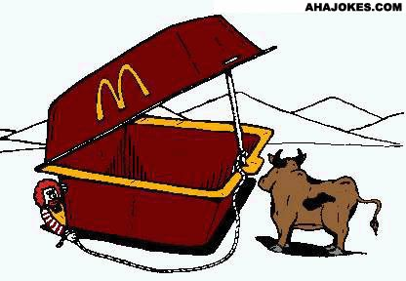

Guest Speakers

ST1

Guest Speaker Notes

Take notes on the content of the guest speaker’s presentation / discussion. Be sure to document the speaker’s name, the date of the presentation and the location of the presentation.

Integrating Guest Speaker Notes

Write your own notes here regarding how the presentation given can be used in your own project / research work.

Announcements

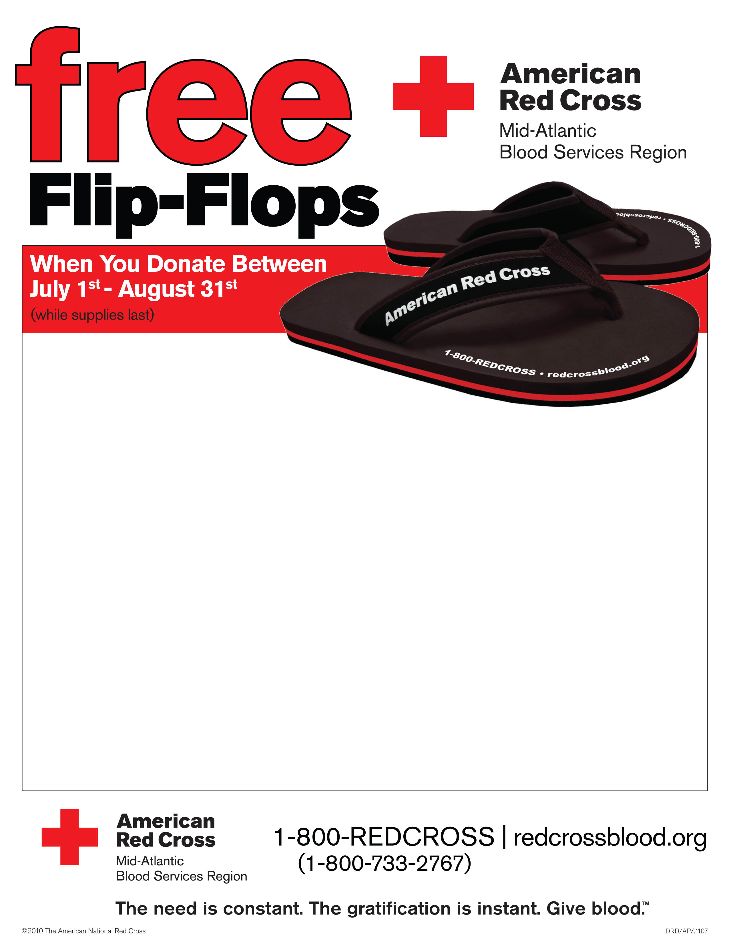

Tallwood High School

1668 Kempsville Road

BLOOD DRIVE

Tuesday, July 27th

1:30pm-5:30pm

(In the cafeteria)

To donate, you must be at least 17(16 with parental consent).

A valid photo ID is required for all donors

*Leaflet / Flyer / Announcement*

*5 W Test*

*The Use of Templates*

*A Telling Image*

*Special Attention Grabbers*

*Use of Teasers*

<http://www.archive.worldpressphoto.org/search/layout/result/indeling/detailwpp/form/wpp/q/ishoofdafbeelding/true/trefwoord/year/1980>

<http://www.archive.worldpressphoto.org/search/layout/result/indeling/detailwpp/form/wpp/q/ishoofdafbeelding/true/trefwoord/year/1989>

<http://www.defenestration.net/>

ST2

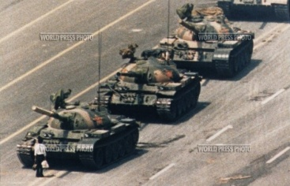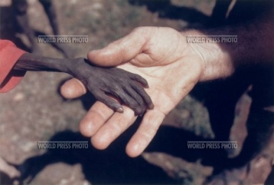



Announcements

*These criteria may seem painfully obvious, but it is amazing how many items of these are missed on a flyer. It is therefore of paramount importance for the designer to get a second, third, fourth opinion to see if anything is missing and gather intel on the general response to the flyer.*

WHEN: Date and Time

Wednesday May 5th, 2010 at 7:30 p.m.

WHERE: Place

Philippine Cultural Center

730 Baxter Road

Virginia Beach, Virginia 23462

(Off Kempsville Road)

(See map below)

WHAT: Activities taking place, Title, Theme

Cultural Dance Showcase

Food, Fun, and Top Dancers will Entertain YOU!

WHY: Persuasive

In Celebration of Philippine history

WHO: Come One, Come All ! (Must be 18 or accompanied by a paying adult) Kids eat free!

HOW: Price: $50 a ticket, Free to everyone, buy one get one free, Coupon Books Available.

Ask about our Group Rates! All Major Credit Cards Accepted. Make Checks payable to …. As Seen on Regis! As seen on Good Morning America! Operating Hours: _________, Open 24/7, Closed on Sabbath, Closed on Sundays, Opening Hours: ___________

*You are the proprietor of a toilet business, meaning you have an employee collect money for visitors to use the toilets. This month, as competition is getting fierce, you’ve decided to have a toilet promotional campaign, complete with flyers, discounts and some good ol’ fashioned family fun!*

*You will be assigned a business to the left to get you started. When you’re finished with your business, all flyers will be scrutinized by our crackerjack panel of classroom judges, who will check for the items above and give their opinion on if they simply like it or not.*

OTHER: Creativity, Colours, Pictures, Attention Grabbers

EXTRA! EXTRA! EXTRA!

TOILET COMPETITION

1. Williamsburg
2. Beachfront
3. House of Horrors
4. Langley Air Force Base (NASA)
5. Native America
6. Hollywood
7. Texas Ranch
8. Disney World

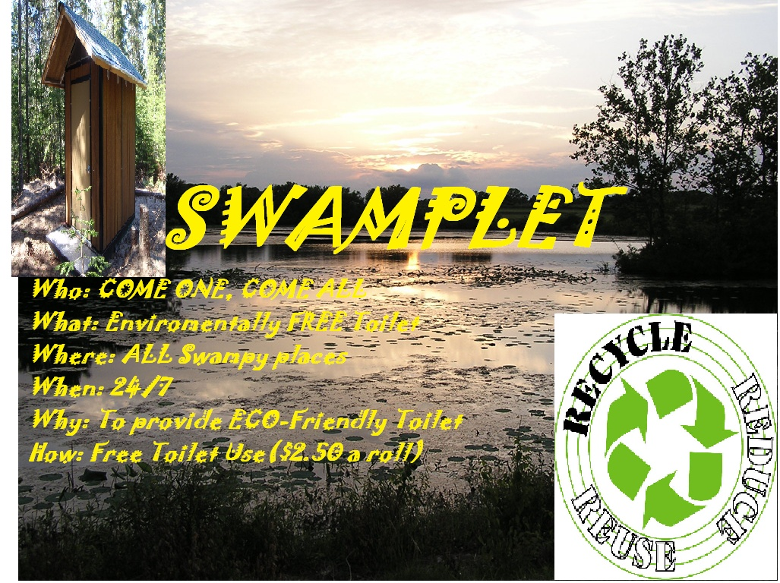

*Does this one work for you?*

*(Designed for the Dismal Swamp Toilets)*

*Why or why not?*

Letters

1a 1b 1c

2a / 2b 2c

3

4

5 (optional)

6

7

8

9

10

11(optional)

*Three Tactics*

*Cloth and Thread*

*“Flaczki” Sandwich*

*Thesaurus (Keyword) Tactic*

If the above template represents a business letter, where would the following items go?

Please note the a, b, or c attached to items 1 and 2 represent optional placement. If 1a is placed in the upper left corner, for example, then the placement for 2a would be used, etc.

Write down the corresponding number referring to placement as well as any needed notes.

*Signature*

*Date*

*Senders Address (or if preprinted, sender’s name and address)*

*Sender’s Position*

*Closing*

*Salutation*

*Subject line*

*Receiver’s Title, Name, Address*

*Text of letter*

*Printed name (title)*

*Enclosures*

Situational Writing

In groups, work out the details of the following letters.

Will there be any special techniques you use as you consider your audience?

Which one(s)?

Why these?

After working out the details, chose one situation to use to write your letter.

Situation 1

Encourage kids to have their parents buy the latest “SuperDuper Extra Wonderful Yo-Yo!!!”

Situation 2

Explain to a customer why they will not get their promised 15% discount on their purchased toaster oven .

Situation 3

Convince your laborers to give up Saturday extra pay and put in extra hours.

Situation 4

Apologize to a customer for the rude behavior of your travel agent.

Situation 5

Congratulate a couple on their 50th wedding anniversary. Offer them a vacation cruise with a 10% discount.

Situation 6

Cancel your order of 100 tuxedos for your production of Guys and Dolls set for June of this year.

Situation 7

Convince an Ivy League university to accept your son/daughter as a student despite a D average.

Marketing: 

I am a Senior of the GSWLA at Tallwood High School. Shirts4Smiles is my senior project as part of my Global Connections course for the Academy in which I am hand-screenprinting v-neck t-shirts to be sold at THS, PAHS, & LHS. 100% of all proceeds will be donated to Operation Smile, a global medical charity focused on providing surgeries for kids with cleft lips and cleft palates

Purpose of design: The design itself says “i made a difference” inside an upside-down speech bubble. Yes, it is meant to be upside down, I designed this logo to be a literal personal statement. When one wears the shirt and looks down it is a reminder that the money used to purchase that shirt is their contribution to making someone else around the world smile

WHAT MAKES THEM UNIQUE?:  
• V-Necks: V-necks are becoming a popular fashion trend. Fundraising shirts typically do not offer v-necklines.   
  
• Hangtag: My shirts are completely customized. A hangtag, a canvas, rectangular patch is sewn to the bottom left-hand edge of the v-neck. On it is the official Operation Smile logo. No other shirts have a hangtag. This is not a typical fundraising shirt to be hung up in the back of a closet. I want my customers to be able to wear this shirt anywhere and everywhere.  
  
• Sizes: My shirts come available in MENS and WOMEN’S fits. The women’s fit shirts are more tailored to the female body.   
  
• Packaging: All shirts come individually packaged in a presentable, plastic wrapping, not just sold out of a box.   
  
• Goodies: All purchases come with Operation Smile temporary tattoos donated from Operation Smile.   
  
• Production: Shirts are hand-screened by me and a team of volunteers with screen printing equipment. My shirts are made with love.  
___________________________________________  
PREORDER ONLY, FIRST COME, FIRST SERVE.  
V-Neck Shirts are ALL $15  
CHECKS ONLY   
 WHITE: MENS/WOMENS S-L  
 BLACK: MENS/WOMENS S-L  
 CAROLINA BLUE: WOMENS ONLY S-L  
 ROYAL BLUE: MENS ONLY S-L  
Order Forms available in (main office, academy board)  
Turn in all checks to (Tallwood Mr. De Mott rm 300)  
  
Feel free to contact me via email or Facebook with any questions, comments, or concerns.   
  
Sincerely, Nerissa Monton

Text adapted from: [www.facebook.com/group.php?gid=375477867453&v=wall](http://www.facebook.com/group.php?gid=375477867453&v=wall)

Devil in the Detail

Kelly Brinkman, recipient of the 2009 Scholarship for Outstanding Senior Project (Spring), presented to the Round II board having brought with her the required trifold for her Tallwood “Green Roof” proposal. While making the trifold, she followed all the good guidelines outlined below. Alongside this was a scaled replica of Tallwood’s gymnasium, complete with a grassed roof. During the question and answer period of her presentation she would not give “I don’t know” as an answer, and continued to sell her product until her time was up. Kelly, like others, knew that the devil was in the details, the extra something that made her project unique.

Look at the Shirts4Smiles Facebook announcement by Nerissa Monton (2010) who covered all sorts of details one would not think of off the bat. Through her text, she continues to sell her product with good word choice and positive connotations (e.g. “My shirts are made with love”). By the end of the semester with fantastic sales, the “i made a difference” t-shirts were practically a Tallwood brand, as well as a successful fundraiser for Operation Smile.



*Is my visual:*

1. *Attractive, creative, interesting?*
2. *Clear without any unwanted or unnecessary images?*
3. *Honest, or if not, at least humorous?*
4. *Neither too crowded or too barren (unless this is the visual goal)*

*Is my text:*

1. *Logically or creatively organized?*
2. *Properly mooded?*
3. *Inclusive of all the necessary information?*
4. *Inclusive of any interesting or attractive facts without being distracting?*
5. *Personal, yet professional?*

*Are they both:*

1. *Mindful of the overall goal or mission*
2. *Complementary to any visual message?*
3. *Respectful and without any vulgarity?*
4. *Considerate of the potential readership?*
5. *Neat and presentable?*

*Are there extra incentives to coming aboard? What are they?*

*Adapted from Appleby 78-80.*

Appeals

Briefly describe each of the types of appeals, then rearrange the boxes to match the type of appeal.

MLK’s ‘I have a dream” abridged

<http://www.youtube.com/watch?v=KUP_ISA030c&feature=related>

Just close the … border already. We don't need this… from a second rate power with a cultural bias. They have no respect for us, and aren't willing to play by our rules. …Turks who want to emigrate legitimately and are willing to integrate will remain entirely welcome. (From the Local (Germany’s English language newspaper) as a reaction to an article saying Turks refuse to assimilate to German culture.) <http://www.thelocal.de/society/20100317-25933.html>

Charlton Heston’s “From My Cold Dead Hands” Speech

<http://www.youtube.com/watch?v=5ju4Gla2odw>

United Nations speech by President Hugo Chavez (Venezuela) on newly elected President Obama <http://www.youtube.com/watch?v=he9r-hW2egc>

Bin Laden’s son calls for Peace

<http://www.youtube.com/watch?v=GY4wGpPbz0E&feature=related>

United Nations Speech by President Qaddafi (Libya) on Taliban and Civil War

<http://www.youtube.com/watch?v=67vSQN3Ga1s&feature=related>

John Lipsky, First Deputy Managing Director, IMF

Finally, what can we learn from the Liberian experience that can apply beyond its immediate borders and those of its neighbors in West Africa? The story shows that, *given strong national leadership*, a coordinated combination of military, humanitarian, technical, and financial assistance can help to turn around failed states. Liberia’s post-conflict recovery is not a “first” but it provides a clear illustration of how coordinated and sustained multilateral support can help national leaders deliver impressive results.

From “Liberia: Life after Debt” See entire speech at: <http://www.imf.org/external/np/speeches/2010/063010.htm>

United Nations speech by President Hugo Chavez (Venezuela) on American Imperialism <http://www.youtube.com/watch?v=ciPH-Ke6FE8&feature=related>

[Father of Columbine victim](http://www.imdb.com/name/nm1285150/):

I am here today because my son Daniel would want me to be here today. If my son Daniel was not one of the victims, he would be here with me today. Something is wrong in this country when a child can grab a gun, grab a gun so easily, and shoot a bullet into the middle of a child's face, as my son experienced. Something is wrong. But the time has come to come to understand that a Tech-9 semi-automatic -bullet weapon like that, that killed my son, is not used to kill deer. It has no useful purpose. It is time to address this problem.

From Bowling for Columbine

Voices from the Global South on African Debt Relief

<http://www.youtube.com/watch?v=4K8JZ_Xkmmo>

Messages Sent / Messages Received

 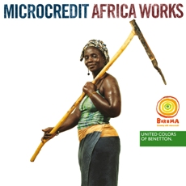

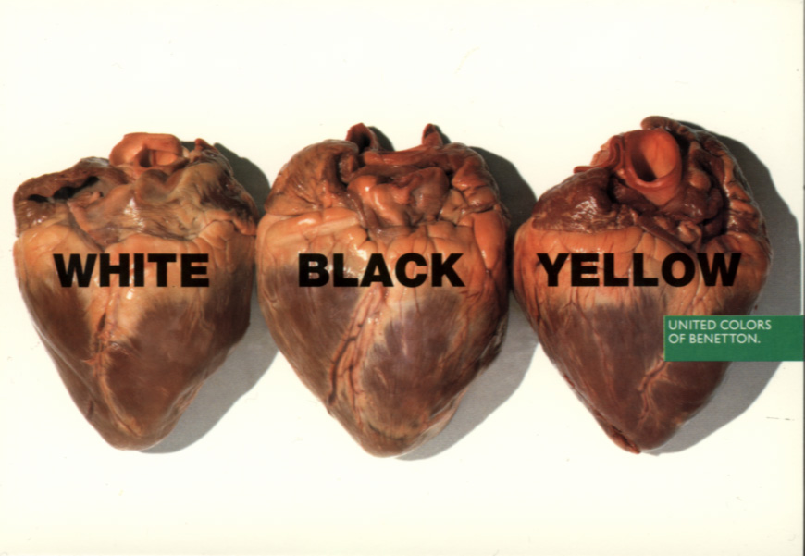 [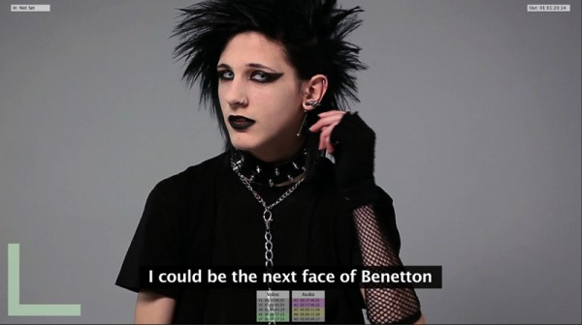](http://trendland.net/2010/02/09/benetton-international-casting/)

 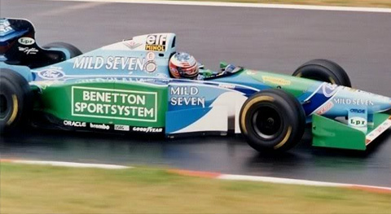

<http://le-boc-lounge.blogspot.com/2009/11/united-colors-of-benetton.html>

<http://operachic.typepad.com/opera_chic/2007/12/united-colors-o.html>

<http://www.tendances-de-mode.com/en/2009/03/19/1269-benetton>

<http://optimistworld.com/Benetton-Funds-Micro-Credit-Scheme-in-Senegal>

<http://trendland.net/2010/02/09/benetton-international-casting/>

<http://www.formula1blogger.com/tag/benetton/>

<http://www.logodesignlove.com/30-logo-design-love-reader-favourites> [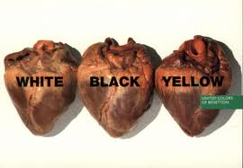](http://www.google.com/imgres?imgurl=http://2.bp.blogspot.com/_3ZpOXzSXCzQ/SwRW5MAraJI/AAAAAAAAAio/Tr6rQVOcSD8/s1600/benetton.jpg&imgrefurl=http://le-boc-lounge.blogspot.com/2009/11/united-colors-of-benetton.html&usg=__l2eoukWHoUO--q0IiVcRjP7kqYw=&h=601&w=870&sz=117&hl=en&start=0&sig2=SBx_ufuo-bxL7J8zSuTQEQ&zoom=1&tbnid=dB2I5iNEMOruVM:&tbnh=131&tbnw=190&ei=S1l2TIWkBIGisAPnx82gDQ&prev=/images?q=benetton&hl=en&biw=1276&bih=615&gbv=2&tbs=isch:1&itbs=1&iact=hc&vpx=818&vpy=119&dur=280&hovh=187&hovw=270&tx=146&ty=120&oei=S1l2TIWkBIGisAPnx82gDQ&esq=1&page=1&ndsp=17&ved=1t:429,r:4,s:0)[](http://www.google.com/imgres?imgurl=http://2.bp.blogspot.com/_3ZpOXzSXCzQ/SwRW5MAraJI/AAAAAAAAAio/Tr6rQVOcSD8/s1600/benetton.jpg&imgrefurl=http://le-boc-lounge.blogspot.com/2009/11/united-colors-of-benetton.html&usg=__l2eoukWHoUO--q0IiVcRjP7kqYw=&h=601&w=870&sz=117&hl=en&start=0&sig2=ATewfmLOPciTZT6AQpAp2A&zoom=1&tbnid=dB2I5iNEMOruVM:&tbnh=131&tbnw=190&ei=S1l2TIWkBIGisAPnx82gDQ&prev=/images?q=benetton&hl=en&biw=1276&bih=615&gbv=2&tbs=isch:1&itbs=1&iact=hc&vpx=818&vpy=119&dur=4850&hovh=187&hovw=270&tx=150&ty=105&oei=S1l2TIWkBIGisAPnx82gDQ&esq=1&page=1&ndsp=17&ved=1t:429,r:4,s:0)

Negative Advertising

[](http://www.despair.com/somevedi.html)[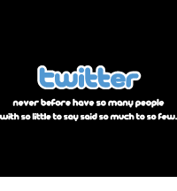](http://www.despair.com/twitter.html)[](http://www.despair.com/gomo.html)[](http://www.despair.com/bp.html)[](http://www.despair.com/goldman.html)[](http://www.despair.com/toyota.html)

Discussion Prompts:

-Is it true that a picture says a thousand words?

-What has a more lasting image, positive or negative advertising?

-Are these images fair? Does fairness matter in the public’s eye?

All images from: <http://www.despair.com/deviall1.html>

Discussion Types

What are the essential similarities and differences between the Socratic Seminar and a Touchstones Discussion? Be prepared to conduct both types after looking at the readings in the section marked readings.

ST3

Think about other discussions you’ve had, be it the Church meeting, the classroom debate, an international videoconference, a parental chat, or just hanging out with friends. What are the Pitfalls of any discussion?

Modes of Delivery

Throughout this seminar, you will get many chances to lead, to moderate, to facilitate to interview and be interviewed, to represent, and to ruminate your expertise on a chosen field of study. Your project may require some skills not mentioned here.

Throughout this manual there are some examples of the following:

Discussion Types/ Modes of Delivery

Socratic Seminar

Touchstones Discussion

Fishbowl

Interviews

Pair and Share

Presentations

Hot-Seat

Round Robin

Jigsaw

Parliamentary Procedure

Videoconferencing

Podcasting

Godcasting

Be sure that you know the following:

* + 1. The definition or process of each of these
    2. The content
    3. Preparation necessary to accomplish the task
    4. The audience or readership
    5. The audience’s knowledge of the content
    6. The expectations of the audience
    7. Whether or not you’ll be going it solo
    8. Your own expectations
    9. The background/venue in which you will present
    10. Pitfalls of this role
    11. How you will be evaluated
    12. What you have learned from the experience

Some explanations can be found at

[*http://vudat.msu.edu/forum_types/*](http://vudat.msu.edu/forum_types/)

*Tips on discussions can be found at*

[*http://www.hrea.org/pubs/tips-discussion.html*](http://www.hrea.org/pubs/tips-discussion.html)

*Tips for creating discussion questions can be found at*

[*http://homepages.wmich.edu/~acareywe/discussion.html*](http://homepages.wmich.edu/~acareywe/discussion.html)

*Tips on Parliamentary Procedure*

[*http://www.rulesonline.com*](http://www.rulesonline.com)

*Tips for running a video-conference*

[*http://www.psy.gla.ac.uk/~steve/resources/VidConfTips.html*](http://www.psy.gla.ac.uk/~steve/resources/VidConfTips.html)

*For sample Podcast* [*http://www.podcastdirectory.com/podshows/1611382*](http://www.podcastdirectory.com/podshows/1611382)

*For sample Godcast* [*http://www.godcast.org/2008/09/02.html#a5614*](http://www.godcast.org/2008/09/02.html#a5614)

Question and Answer Hot Seat

Questions should relate to the student’s research, but be persistent and on target. Deeper level questions should keep the student in the explanatory mode as long possible.

Student in the Hot Seat should answer the questions, not “beat around the bush” and try to stay in the Hot Seat as long as possible.

The idea is not to “catch” the student in the Hot Seat, but rather to get to the core of the question and understand the student’s take/stand on the issue.

Out of the Hot Seat (Questions)  In the Hot Seat (Answers)

Parliamentary Procedure through the Model UN

Answer the following questions from the website <http://www.wmhsmun.org/documents/WM%20IR%20Club%20Guide%20to%20MUN.pdf>

* 1. What do you say if you object to a procedural error?
  2. When do you say “Point of Parliamentary Inquiry?”
  3. It what two cases can you (possibly) interrupt the speaker?
  4. What item needs 2/3 vote to be passed?
  5. Name three cases where you need to be seconded and three cases where you do not need to be seconded.
  6. What are the three suggestions on conducting delegate training?
  7. What’s the difference between a moderated caucus and an unmoderated caucus?
  8. What are the two things a Topic needs in a Position Paper?
  9. Define: Heading, Preambatory Clause, Operative Clause.
  10. What are 10 common phrases that can be used in resolutions?
  11. What are the suggested sites for researching a country? A topic?
  12. Looking at the bibliography, how can this PDF help you in your own research?
  13. Name three bodies from the UN; what do they do?
  14. Who are the permanent members of the UN? At present, who are the non-permenant members?
  15. What does the third committee of the General Assembly do?
  16. How can Step Four (Foreign Policy related to topic) assist you in Global Connections?
  17. Pick two questions from Step Two (International Perspective) and apply it to your research.
  18. What is the procedure of the voting process on draft resolutions? Why do you think this is the case?
  19. What is a dais?
  20. What are the roles of members of the dais?

http://www.wmhsmun.org/assets/img/tiny_logo.pngWilliamsburg, Virginia, 12 - 14 November, 2010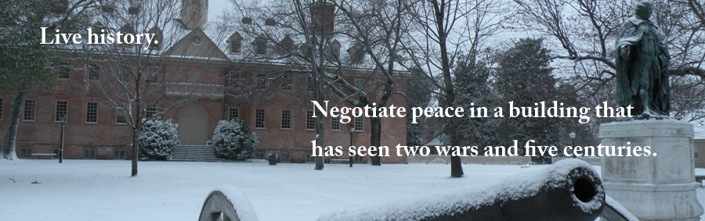

Position Papers and Research

Students will work with juniors to learn about Parliamentary Procedure and do research on the three topics below. In simulation, the students will prepare preliminary research on and a position paper (three paragraphs- one for each topic) based on the point of view of a particular country. Country assignments will be given at a later date, as well as background information (posted on the William and Mary website at <http://www.wmhsmun.org/?cmd=showtopic&id=79>).

Students should note that there are more topics that may assist them in their actual research / project work, however the three below are the ones we will be using for a classroom activitity.

The activity is to get students to learn through practice as well as mentor juniors. Should students wish to take on a project related to these items, they have support around every corner. Moreover, students who wish to complete their outside presentation may do so through following up on the days spent with the juniors by joining the competition for Model UN and making presentations. They should be sure to follow the procedure laid out on the page entitled “Outside Presentations” so that they can receive credit.

Point of view is a huge portion of writing any research paper and/or implementing a project. This activity will assist students to think outside the media driven point of view, and ultimately, give them a great resource for globalizing their paper and/or project.

Assigned Country: _____________________________________________________________________

**Topic:** Children in Combat/Child Soldiers  
**Committee:** Social, Humanitarian & Cultural

Children in Combat/Child Soldiers: Throughout history and in many cultures, children have been used in military campaigns, taking part in direct hostilities, supporter roles of spies, messengers, or lookouts, and even as human shields. Efforts have been made since the 1970s to limit the participation of children in armed conflict, but more needs to be done.

**Topic:** Illegal Immigration and Refugees  
**Committee:** Social, Humanitarian & Cultural

Illegal Immigration and Refugees: The refugee issue is one that has long been on the mind of the international community - in recent years, the problem has expanded, creating a whole new set of dilemmas. Short-term issues include the creation of refugee camps, while long-term issues remain - whether to incorporate the refugees into the nation or wait until they choose to voluntarily repatriate, to name a couple.

**Topic:** Euthanasia  
**Committee:** Social, Humanitarian & Cultural

Euthanasia: Referring to the practice of ending life in a painless manner, euthanasia is a highly debated issue that brings with it controversy on all sides of the spectrum - social, humanitarian, and cultural. Many countries' laws are unspecific and unclear about the issue, and rulings seem to differ and contradict one another. Something justified always has the potential to be interpreted and exploited in such a manner that causes more harm than benefit, and as such, this issue is a hot topic.

Videoconferencing Summaries:

Discuss the “articles from the class wiki form the fictional newspaper called Video-Conferencing Today. In one paragraph describe the content of the articles. In a second, bring in your own personal experience with Video-Conferencing. Share your thoughts with your neighbor. Then share with the class. (This is sometimes called Pair and Share, and allows everyone to get a chance to talk, even if it is on a one to one basis

Contents of the article

Personal Experiences with Video-Conferencing

Positive

Negative

Analysis of the Work of Others

Movies

Connection between Content/ Technical/ Artistic

Artistic Aspect

Technical Aspects

Content / Message

Storyboarding

X-men Style

*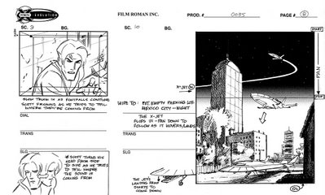These are two samples that show movement, give direction, show order and show object placement and expression desired.*

From: <http://rocketfiction.blogspot.com/2006/11/x-men-storyboard-pages.html>

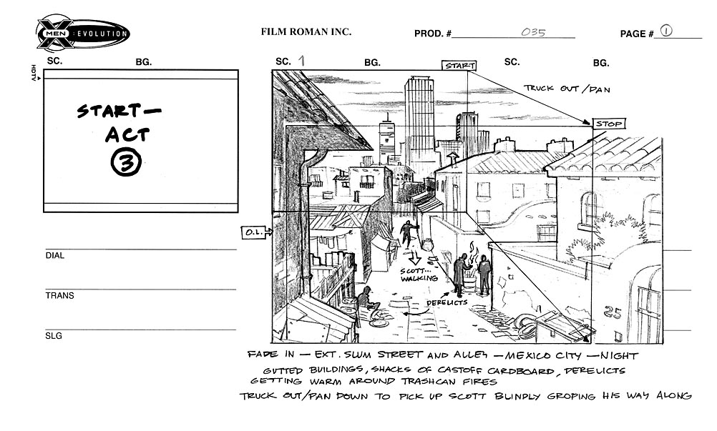

Downloads of blank templates can be obtained at <http://xinsight.ca/tools/storyboard.html>

There are numerous programs out there: some to consider are Moviemaker and PhotoStory3 (free download <http://www.microsoft.com/windowsxp/using/digitalphotography/photostory/default.mspx> )

Globalizing the Ostensibly Local

To avoid national exceptionalism, or any other type of exceptionalism for that matter, it is important to pepper your research with examples from sources “close to home.” Often we are trapped into believing we somehow are different from the rest of humanity, that we, in some way, represent the exception to the rule, and thus, in a bizarre twist of logic, that we are better in our differentness

Source: What is the background of where the material came from. Does the source increase or decrease the validity of the material?

Spin: What truth is being proven in the way something is reported and/or delivered? What might the motivation for this spin be?

Significance: What is the broad importance of this event/phenomenon? What impact was made on the nature of the theme after this event /phenomenon took place?

Big Picture: How does this event/phenomenon relate to the theme overall? Are there sufficient examples from various sources to qualify it as a rule, rather than an exception to the rule. This can be seen as the broad thesis, and will no doubt contribute to the overall thesis as more sources are researched.

Blinders: What factors prevent truly seeing the relationship between the theme and the big picture/ broad thesis. Are these blinders distracters from the truth or factors to the truth?

Variety: Are various sources from different localities, different time periods, different genres, different class systems, government systems, or belief systems represented?

Discussion: The analysis from the researcher based on all the above is in some ways the most important part. While looking at the above in detail, a researcher should express the validity of the sources, and thus, find his/her voice in the process.

Always there should be local examples so that the researcher gets into the habit of not only looking without, but also, looking within.

ST4

|  |  |
| --- | --- |
| Reading (found in the Reading Section) | -THE INDISPENSABLE ROLE OF WOMEN IN VIRGINIA  - WOMEN AND THE AMERICAN REVOLUTION |
| Source | Courtesy the Colonial National Historic Park:  Historic Jamestowne and Yorktown Teacher Packet |
| Spin |  |
| Significance |  |
| Broad Thesis |  |
| Blinders |  |
| Variety |  |
| Discussion |  |

|  |  |
| --- | --- |
| Reading / Image / Item being researched |  |
| Source |  |
| Spin |  |
| Significance |  |
| Broad Thesis |  |
| Blinders |  |
| Variety |  |
| Discussion |  |

Focus Activity

The Marketing of Gender Roles in Bollywood

Sometimes we can formulate opinions based on the opinions of others – sometimes, however, this is just the regurgitation of the opinions of others…

How can you make an argument your own, while still using a series of opinion from others? Well, putting a little of you into the picture can sure help. If you come from a place that you know about and put it next to a place that you don’t know so much about in the same field, you may have an interesting, self generated opinion to share.

Browse through these articles on gender and movies (in Bollywood). We’ve all bumped into a member of the opposite sex (and perhaps have an opinion about it). And we’ve all been to a movie before (and probably have our preferences) Compare what you know (perhaps Hollywood) with something your not as certain of (perhaps Bollywood).

Write a short piece and then podcast your opinions in a brief (under two minutes statement on gender roles in the movies. Although hugely research based, try to make the majority of your podcast come from you, rather than the sources.

<http://www.chowk.com/articles/10576>

<http://womensmediacenter.com/blog/2009/10/gender-discrimination-in-filmmaking%E2%80%94bollywood-style-by-sharmeen-gangat>

<http://www.google.com/hostednews/afp/article/ALeqM5ijgadD0VebZuv0lzn-W3VlifbALg>

<http://timesofindia.indiatimes.com/entertainment/bollywood/news-interviews/Whats-gender-got-to-do-with-acting/articleshow/5679501.cms>

<http://www.nytimes.com/2006/07/30/movies/30chop.html>

Notes for your text