PERSIA READINGS October
Theme: Authority
- P: The Mongol Art of War
- E: Red Seal Ships (Japan)
- R: Filial Piety
- S: Quarish Tribe on the Eve of Islam
- I: Citadels (pictures)
- A: Chinese Art (Cultural Revolution)

Political
The Mongol Art of War
Mongols prized their commercial and trade relationships with neighboring economies and this policy they continued during the process of their conquests and during the expansion of their empire. All merchants and ambassadors, having proper documentation and authorization, traveling through their realms were protected. This greatly increased overland trade. During the thirteenth and early fourteenth centuries, European merchants, numbering hundreds, perhaps thousands, made their way from Europe to the distant land of China Marco Polo is only one of the best known of these. Well-traveled and relatively well-maintained roads linked lands from the Mediterranean basin to China. The Mongol Empire had negligible influence on seaborne trade.
The Mongol Empire had an ingenious and efficient mail system for the time, often referred to by scholars as the Yam, which had lavishly furnished and well guarded relay posts known as örtöö set up all over the Mongol Empire. The yam system would be replicated later in the U.S. in form of the Pony Express. A messenger would typically travel 25 miles (40 km) from one ordu to the next, and he would either receive a fresh, rested horse or relay the mail to the next rider to ensure the speediest possible delivery. The Mongol riders regularly covered 125 miles per day, which is faster than the fastest record set by the Pony Express some 600 years later.
Mongol invasion of Central Asia initially was composed of Genghis Khan's victory and unification over the Mongol central Asian confederations such as Merkits, Mongols, Uighurs that eventually created the Mongol nation and founding of the Mongol Empire. It then continued with invasion of Khwarezmid Empire in Persia.
The Mongol invasion of the Middle East consists of the conquest, by force or voluntary submission, of the areas today known as Iran, Iraq, Syria, and parts of Turkey, with further Mongol raids reaching southwards as far as Gaza into the Palestine region in 1260 and 1300. The major battles were the Battle of Baghdad (1258), when the Mongols sacked the city which for 500 years had been the center of Islamic power; and the Battle of Ain Jalut in 1260, when the Muslim Egyptian Mamluks, with some unusual provisioning assistance from the Christian European Crusaders, were for the first time able to stop the Mongol advance at Ain Jalut, in the northern part of what is today known as the West Bank. Due to a combination of political and geographic factors, such as lack of sufficient grazing room for their horses, the Mongol invasion of the Middle East turned out to be the farthest that the Mongols would ever reach, towards the Mediterranean and Africa.
Mongol invasion of East Asia refers to the Mongols 13th and 14th century conquests under Genghis Khan and his descendants of Mongol invasion of China, Korea, and attempted Mongol invasion of Japan, and it also can include Mongols attempted invasion of Vietnam. The biggest conquest was the total invasion of China in the end.
Mongol invasion of Europe largely constitute of their invasion and conquest of Kievan Rus, much of Russia, invasion of Poland and Hungary among others.
Hulagu, Genghis Khan's grandson and founder of the il-KhanAt first, the Mongol Empire was ruled by Ögedei Khan, Genghis Khan's third son and designated heir, but after his death in 1241, the fractures which would ultimately crack the Empire began to show. Enmity between the grandchildren of Genghis Khan resulted in a five year regency by Ögedei's widow until she finally got her son Guyuk Khan confirmed as Great Khan. But he only ruled two years, and following his death he was on his way to confront his cousin Batu Khan, who had never accepted his authority, another regency followed, until finally a period of stability came with the reign of Mongke Khan, from 1251-1259. The last universally accepted Great Khan was his brother Arigboh (aka. Arigbuga, or Arigbuha), his elder brother Kublai Khan dethroned him with his own supporters after some extensive battles. Kublai Khan ruled from 1260-1294. Despite his recognition as Great Khan, he was unable to keep his brother Hulagu and their cousin Berke from open warfare in 1263, and after Kublai's death there was not an accepted Great Khan, so the Mongol Empire was fragmented for good.
Genghis Khan divided his realm into four Khanates, subdivisions of a single empire under the Great Khan (Khan of Khans). The following Khanates emerged after the regency following Ögedei Khan's death, and became formally independent after Kublai Khan's death:
Blue Horde (under Batu Khan) and White Horde (under Orda Khan) would soon be combined into the Golden Horde, with Batu Khan emerging as Khan.
Il-Khanate - Hulegu Khan
Empire of the Great Khan (China) - Kublai Khan
Mongol homeland (present day Mongolia, including Kharakhorum) - Tolui Khan
Chagatai Khanate - Chagatai Khan.
The empire's expansion continued for a generation or more after Genghis's death in 1227. Under Genghis's successor Ögedei Khan, the speed of expansion reached its peak. Mongol armies pushed into Persia, finished off the Xia and the remnants of the Khwarezmids, and came into conflict with the Song Dynasty of China, starting a war that concluded in 1279 with the conquest of populous China, which then constituted the majority of the world's economic production. In the late 1230s, the Mongols under Batu Khan invaded Russia and Volga Bulgaria, reducing most of its principalities to vassalage, and pressed on into Eastern Europe. In 1241 the Mongols may have been ready to invade Western Europe as well, having defeated the last Polish-German and Hungarian armies at the Battle of Legnica and the Battle of Mohi. Batu Khan and Subutai were preparing to start with a winter campaign against Austria and Germany, and finish with Italy. However news of Ögedei's death spared Western Europe as Batu had to turn his attentions to the election of the next Great Khan. It is often speculated that this was one of the great turning points in history and that Europe may well have fallen to the Mongols had the invasion gone ahead. During the 1250s, Genghis's grandson Hulegu Khan, operating from the Mongol base in Persia, destroyed the Abbasid Caliphate in Baghdad and destroyed the cult of the Assassins, moving into Palestine towards Egypt. The Great Khan Möngke having died, however, he hastened to return for the election, and the force that remained in Palestine was destroyed by the Mamluks under Saif ad-Din Qutuz in 1261 at Ayn Jalut.
Essentially, only six areas accessible to the Mongols avoided conquest by them -- Indochina, South Asia, Vietnam, Japan, Western Europe and Arabia. Also, two important cities that evaded the Mongol Conquest were Vienna and Jerusalem. Both evaded the conquest because of the death of a Great Khan.
While the Mongolian Empire extended into Poland and threatening present day Austria, the Mongols were not able to push into Western Europe. The most popular explanation was the fact that on 11 December 1241, during pre-emptive operations by Mongol reconnaissance forces inside Austria for the invasion of Vienna, news came that Ogedei Khan died, and bound by Mongol tradition, all Mongol commanders and princes had to report back to the capital of Karakorum to elect a new Khan. It was believed that the Mongol abandonment of the European campaign was only temporary, but in fact, the Mongols had committed no further campaigns into Europe in earnest. Some western historians attribute European survival to Mongol unwillingness to fight in the more densely populated German principalities, where the wetter weather affected their bows. But the same weather did not stop them from devastating Russia or the campaigns against the Southern Song, and Europe was less densely populated than China. The probable answer for the Mongol's stopping after the Mohi River, and the destruction of the Hungarian army, was that they never intended to advance further at that time. Batu Khan had made his Russian conquests safe for the next 10 generations, and when the Great Khan died, he rushed back to Mongolia to put in his claim for power. Upon his return, relations with his cousin Guyuk Khan had deteriorated to the point that open warfare between them came shortly after Guyuk's death. The point is that the Mongols were unable to bring a unified army to bear on either Europe, or Egypt, after 1260. Batu Khan was in fact planning invasion of Europe all the way to the "Great Sea" the Atlantic Ocean, when he died in 1255. His son inherited the Khanate, but also died in a short time, and Batu's brother Berke became Khan of the Kipchak Khanate. He was far more interested in fighting with his cousin Hulagu than invading the remainder of Europe, which was no threat to him.
Another area not conquered by Mongols was Vietnam, which repelled Mongol attacks in 1257/1258, 1284/1285 and 1287/1288. Japan also repelled massive Mongol invasions in 1274 and 1281. Japan's ruler Hojo Tokimune first sent back the emissaries time and time again without audience in Kamakura, and then after the first invasion was so bold as to behead Kubilai's emissaries, twice. In both Japan and Vietnam, Kubilai sent part of the Mongol armies, instead of concentrating on Vietnam first, and then Japan. Furthermore, the splitting of resources left the Mongols with a fleet that was not readily equipped for the storms that plagued the Sea of Japan. A great storm sank the primary invasion fleet and killed most of the Mongol army during the 1281 invasion. Nonetheless, Kublai Khan continued to attempt to gather forces for another invasion while simultaneously attacking Vietnam. The end result was Japan was able to repel Mongol assaults, but Vietnam was not.
Many other countries of Indochina could counter the Mongol invasion, such as the Maoluang Kingdom (or Kingdom of Mong Mao) in Northern Thailand, Shan and Kachin in today's Northern and Northeastern Burma as well as Assam in Eastern India and Southwestern China. Sa Khaan Pha (or Si Ke Fa), king of Maoluang Kingdom, was able to negotiate a treaty after he defeated the Mongols three times during the period of Kublai Khan. He received authority over the land south of the Sang city which is now Kunming in the Yunnan province of the People's Republic of China. Lanna and Sibsongpanna in Northern Thailand, Northern Laos and Southern China, Lan Xang in Laos, Champa in Southern Vietnam and Cambodia, the Siamese kingdoms of Chiang Saen (or Chieng Saeng), Lavo, Haripunjai, Phyao and Sukhotai, and the Khmer empire were never touched by the Mongols due to the treaty. However, the Burmese Pagan dynasty was destroyed in 1287 by Kublai Khan as well as the Northern Vietnamese empire of Viet. The Mongol fleets sent to Khmer, Java, Siam, Srivijaya and Malay Archipelago never won any battles.
South Asia was also able to withstand the advance of the Mongols. At this time, Northern India was under the rule of the Delhi sultanate. Though the Mongols raided into the Punjab and invaded Delhi itself (unsuccessfully), the Sultans--mostly notably Ghiyasuddin Balban--were able to keep them at bay and roll them back.
When Genghis Khan died, a major potential weakness of the system he had set up manifested itself. It took many months to summon the kurultai, as many of its most important members were leading military campaigns thousands of miles from the Mongol heartland. And then it took months more for the kurultai to come to the decision that had been almost inevitable from the start that Genghis's choice as successor, his third son Ögedei, should become Great Khan. Ögedei was a rather passive ruler and personally self-indulgent, but he was intelligent, charming and a good decision-maker whose authority was respected throughout his reign by apparently stronger-willed relatives and generals whom he had inherited from Genghis. After the initial massive campaigns at the beginning of the conquest of Europe, where the Mongol war machine handily defeated the Hungarian and Polish armies, the Hospitallers, the Teutonic Knights, as well as the slaughtering of countless many civilians, Ögedei Khan suddenly died in 1241; just as the Mongol forces under General Subutai were preparing an all out assault on Vienna, Austria. This sudden vacuum of power is seen as the beginning of the events that led to the decline of the Mongol Empire. As customary to Mongol military tradition, all generals and princes, and thus the tumens, had to report back to the capital Karakorum thousands of miles away (the relocation of the capital to Dadu would add to this difficulty under Kublai Khan), for the election of a successor to the throne. Pending a kurultai to elect Ögedei's successor, his widow Toregene Khatun assumed power and proceeded to ensure the election of her son Guyuk by the kurultai. Batu, bitterly disappointed by the postponement of the European campaign, was unwilling to accept Guyuk as Great Khan, but lacked the influence in the kurultai to procure his own election. Therefore, while moving no further west, he simultaneously insisted that the situation in Europe was too precarious for him to come east and that he could not accept the result of any kurultai held in his absence. The resulting stalemate lasted four years. In 1246 Batu eventually agreed to send a representative to the kurultai but never acknowledged the resulting election of Guyuk as Great Khan. Guyuk died in 1248, only two years after his election, on his way west, apparently to force Batu to acknowledge his authority, and his widow Oghul Ghaymish assumed the regency pending the meeting of the kurultai. Batu remained in the west but this time gave his support to his and Guyuk's cousin, Möngke, who was duly elected Great Khan in 1251. Möngke Khan unwittingly provided his brother Kublai, or Qubilai, with a chance to become Khan in 1260, assigning Kublai to a province in North China. Kublai expanded the Mongol empire and became a favorite of Möngke. Later, though, when Kublai began to adopt many Chinese laws and customs, his brother was persuaded by his advisors that Kublai was becoming too sinicized and would be considered treasonous. Möngke kept a closer watch on Kublai from then on but died campaigning against Southern Song China at the Fishing Town in Chongqing. After his older brother's death, Kublai placed himself in the running for a new khan against his younger brother, and, although his younger brother won the election, Kublai defeated him in battle, and Kublai became the last true Great Khan. He proved to be a strong warrior, but his critics still accused him of being too closely tied to Chinese culture. When he moved his headquarters to Beijing, there was an uprising in the old capital that he barely staunched. He focused mostly on foreign alliances, and opened trade routes. He dined with a large court every day, and met with many ambassadors, foreign merchants, and even offered to convert to Christianity if this religion was proved to be correct by 100 priests. By the reign of Kublai Khan, the empire was already in the process of splitting into a number of smaller khanates. After Kublai died in 1294, his heirs failed to maintain the Pax Mongolica and the Silk Road closed. Inter-family rivalry compounded by the complicated politics of succession, which twice paralyzed military operations as far off as Hungary and the borders of Egypt (crippling their chances of success), and the tendencies of some of the khans to drink themselves to death fairly young (causing the aforementioned succession crises), hastened the disintegration of the empire. Another factor which contributed to the disintegration was the difficulty of the potential two-weeks extra transit time of officials and messengers and a general decline of morale when the capital was moved from Karakorum to Dadu, the Yuan name for the modern day city of Beijing by Kublai Khan; as Kublai Khan associated more closely to Chinese culture. Kublai concentrated on the war with the Song Dynasty, assuming the mantle of ruler of China, while the khanates to the west gradually drifted away. The four descendant empires were the Mongol-founded Yuan Dynasty in China, the Chagatai Khanate, the Golden Horde that controlled Central Asia and Russia, and the Ilkhans who ruled Persia from 1256 to 1353. Of the latter, their ruler Ilkhan Ghazan was converted to Islam in 1295 and renounced all allegiance to the Great Khan. He actively supported the expansion of this religion in his empire.
The Mongol expansion throughout the Asian continent from around 1215 to 1360 helped bring political stability and re-establish the Silk Road vis-à-vis Karakorum. The 13th century saw a Franco-Mongol alliance with exchange of ambassadors and even military collaboration in the Holy Land. The Chinese Mongol Rabban Bar Sauma visited the courts of Europe in 1287-1288. With rare exceptions such as Marco Polo or Christian missionaries such as William of Rubruck, few Europeans traveled the entire length of the Silk Road. Instead traders moved products much like a bucket brigade, with luxury goods being traded from one middleman to another, from China to the West, and resulting in extravagant prices for the trade goods. The disintegration of the Mongol Empire led to the collapse of the Silk Road's political unity. Also falling victim were the cultural and economic aspects of its unity. Turkic tribes seized the western end of the Silk Road from the decaying Byzantine Empire, and sowed the seeds of a Turkic culture that would later crystallize into the Ottoman Empire under the Sunni faith. Turkic-Mongol military bands in Iran, after some years of chaos were united under the Saffavid tribe, under whom the modern Iranian nation took shape under the Shiite faith. Meanwhile Mongol princes in Central Asia were content with Sunni orthodoxy with decentralized princedoms of the Chagatay, Timurid and Uzbek houses. In the Kypchak-Tatar zone, Mongol khanates all but crumbled under the assaults of the Black Death and the rising power of Muscovy. In the east end, the Chinese Ming Dynasty overthrew the Mongol yoke and pursued a policy of economic isolationism. Yet another force, the Kalmyk-Oyrats pushed out of the Baikal area in central Siberia, but failed to deliver much impact beyond Turkestan. Some Kalmyk tribes did manage to migrate into the Volga-North Caucasus region, but their impact was limited. After the Mongol Empire, the great political powers along the Silk Road became economically and culturally separated. Accompanying the crystallization of regional states was the decline of nomad power, partly due to the devastation of the Black Death and partly due to the encroachment of sedentary civilizations equipped with gunpowder.
The Mongol Empire was the largest contiguous empire in human history. The 13th and 14th century, when the empire came to power, is often called the "Age of the Mongols". The Mongol armies during that time were extremely well organized. The death toll (by battle, massacre, flooding, and famine) of the Mongol wars of conquest is placed at about 40 million according to some sources. Many ancient sources described Genghis Khan's conquests as wholesale destruction on an unprecedented scale in their certain geographical regions, and therefore probably causing great changes in the demographics of Asia. For example, over much of Central Asia speakers of Iranian languages were replaced by speakers of Turkic languages. The eastern part of the Islamic world experienced the terrifying holocaust of the Mongol invasion, which turned northern and eastern Iran into a desert. Between 1220 and 1260, the total population of Persia may have dropped from 2,500,000 to 250,000 as a result of mass extermination and famine. Non-military achievements of the Mongol Empire include the introduction of a writing system, based on the Uyghur script, that is still used in Inner Mongolia. The Empire unified all the tribes of Mongolia, which made possible the emergence of a Mongol nation and culture. Modern Mongolians are generally proud of the empire and the sense of identity that it gave to them.
Some of the long-term consequences of the Mongol Empire include:
The Mongol empire is traditionally given credit for reuniting China and expanding its frontiers. The language Chagatai, widely spoken among a group of Turks, is named after a son of Genghis Khan. It was once widely spoken, and had a literature, but eventually became extinct in Russia. Moscow rose to prominence during the Mongol-Tatar yoke, some time after Russian rulers were accorded the status of tax collectors for Mongols. The Russian ruler Ivan III overthrew the Mongols completely to form the Russian Tsardom, after the Great stand on the Ugra river proved the Mongols vulnerable, and led to the independence of the Grand Duke of Moscow. Europe’s knowledge of the known world was immensely expanded by the information brought back by ambassadors and merchants. When Columbus sailed in 1492, his missions were to reach Cathay, the land of the Genghis Khan. Some research studies indicate that the Black Death, which devastated Europe in the late 1340s, may have reached from China to Europe along the trade routes of the Mongol Empire. In 1347, the Genoese possession of Caffa, a great trade emporium on the Crimean peninsula, came under siege by an army of Mongol warriors under the command of Janibeg. After a protracted siege during which the Mongol army was reportedly withering from the disease, they decided to use the infected corpses as a biological weapon. The corpses were catapulted over the city walls, infecting the inhabitants. The Genoese traders fled, transferring the plague via their ships into the south of Europe, whence it rapidly spread. The total number of deaths worldwide from the pandemic is estimated at 75 million people, there were an estimated 20 million deaths in Europe alone. It is estimated that between one-quarter and two-thirds of the of Europe's population died from the outbreak of the plague between 1348 and 1350.
One of the more successful tactics employed by the Mongols was to wipe out urban populations that had refused to surrender. In the invasion of Kievan Russia, almost all major cities were destroyed. If they chose to submit, the people were spared and treated as slaves, which meant most of them would be driven to die quickly by hard work, with the exception that war prisoners became part of their army to aid in future conquests. In addition to intimidation tactics, the rapid expansion of the Empire was facilitated by military hardiness (especially during bitterly cold winters), military skill, meritocracy, and discipline. Subutai, in particular among the Mongol Commanders, viewed winter as the best time for war while less hardy people hid from the elements, the Mongols were able to use frozen lakes and rivers as highways for their horsemen, a strategy he used with great effect in Russia. The Mongol Empire is also responsible for many technological achievements that are in wide use today. In addition, they discovered a unique way to increase the population of fish in a given body of water. The Mongol Empire had a lasting impact, unifying large regions, some of which (such as eastern and western Russia and the western parts of China) remain unified today, albeit under different rulership. The Mongols themselves were assimilated into local populations after the fall of the empire, and many of these descendants adopted local religions.

Economics http://www.citizendia.org/Red_seal_ships

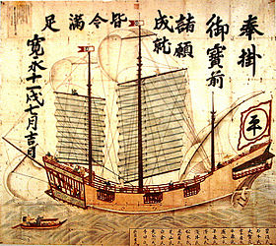
A 1634 Japanese Red seal ship, incorporating Western-style square and lateen sails, rudder and aft designs. RCA Red Seal Records is a prestigious classical music label and is now part of Sony BMG Masterworks. A lateen (from a la trina, meaning triangular or latin-rig is a triangular Sail set on a long yard mounted at an angle on the mast A rudder is a device used to steer a Ship, Boat, Submarine, Hovercraft, or other conveyance that move through a fluid (generally air or The ships were typically armed with 6 to 8 cannons. A ship /ʃɪp/ is a large vessel that floats on water Ships are generally distinguished from Boats based on size Tokyo Naval Science Museum.
Red seal ships (朱印船 Shuinsen) were Japanese armed merchant sailing ships bound for Southeast Asian ports with a red-sealed patent issued by the early Tokugawa shogunate in the first half of the 17th century. For a topic outline on this subject see List of basic Japan topics. The Tokugawa shogunate, also known as the, and the, was a feudal regime of Japan established by Tokugawa Ieyasu and ruled by the Shoguns of Between 1600 and 1635, more than 350 Japanese ships went overseas under this permit system.

Origins
From the 13th to the 16th century, Japanese ships were quite active in Asian waters, often in the role of "Wakō" pirates who plundered the coast of the Chinese Empire. Official trading missions were also sent to China, such as the Tenryūjibune around 1341. Wakō activity was efficiently curbed in the late sixteenth century with the interdiction of piracy by Hideyoshi, and the successful campaigns against pirate activity on the Chinese coast by Ming Dynasty generals.
Between the 15th and the 16th century, the main trading intermediary in Eastern Asia was the island kingdom of the Ryūkyū (modern Okinawa), which exchanged Japanese products (silver, swords) and Chinese products for Southeast Asian sappan wood and deer hides. The Ryūkyū Kingdom ( Ryukyuan: ja 琉球國 rūchū－kuku, 琉球王国 ryūkyū-ō-koku) liúqiúguó) was an independent kingdom which is one of Japan 's southern prefectures, and consists of hundreds of the Ryukyu Islands in a chain over 1000 km long which extends southwest from Kyūshū Altogether 150 Ryukian ships are recorded between the kingdom and Southeast Asia, 61 one of them for Annam (Viet Nam), 10 for Malacca, 10 for Pattani, 8 for Java etc. Patani (Pattani is known to have been part of the ancient Srivijayan kingdom Java (Jawa is an Island of Indonesia and the site of its Capital city Jakarta. . . Their commerce disappeared around 1570 with the rise of Chinese merchants and the intervention of Portuguese and Spanish ships, and corresponds with the beginnings of the Red Seal system. The Ryūkyū kingdom was finally invaded by Japan in 1609.
When the first Europeans started to navigate in the Pacific Ocean (see also Nanban trade period), they regularly encountered Japanese ships, such as when the Spanish welcomed in Manila in 1589 a storm-battered Japanese junk bound for Siam, or when the Dutch circumnavigator Olivier van Noort encountered a 110-ton Japanese junk in the Philippines in December 1600, and on the same voyage a Red Seal ship with a Portuguese captain off Borneo through which they learned about the arrival of William Adams in Japan. The Pacific Ocean is the largest of the Earth 's Oceanic divisions The Nanban trade ( Japanese: 南蛮貿易 nanban-bōeki, "Southern barbarian trade" or the Nanban trade period ( Japanese: 南蛮貿易時代 The City of Manila The Netherlands ( Dutch:, ˈnedərlɑnt is the European part of the Kingdom of the Netherlands, which consists of the Netherlands the Netherlands Olivier van Noort ( 1558 - 22 February 1627) was the first Dutchman to circumnavigate the world -HK CityHall Seaview 51217 5png|thumb|300px|A modern junk in Hong Kong]]A junk is a Chinese sailing vessel. The Philippines ( Filipino: Pilipinas, officially known as the Republic of the Philippines (fil ''Republika ng Pilipinas'' RP Borneo is the third largest island in the world and is located at the centre of Maritime Southeast Asia. For other people called William Adams see William Adams. Early life Adams was born in Gillingham, Kent, England

Red Seal system
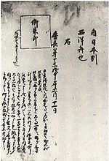
Record of a Red Seal license, dated January 11th, 1608.
The Red Seal system appears from at least 1592, under Hideyoshi, date of the first known mention of the system in a document. The first actually preserved Shuinjō (Red Seal Permit) is dated to 1604, under Tokugawa Ieyasu, first ruler of Tokugawa Japan. was the founder and first Shogun of the Tokugawa shogunate Tokugawa issued red-sealed permits to his favourite feudal lords and principal merchants who were interested in foreign trade. By doing so, he was able to control Japanese traders and reduce Japanese piracy in the South Sea. His seal also guaranteed the protection of the ships, since he vowed to pursue any pirate or nation who would violate it.
Besides Japanese traders, 12 European and 11 Chinese residents, including William Adams and Jan Joosten, are known to have received permits. For other people called William Adams see William Adams. Early life Adams was born in Gillingham, Kent, England Jan Joosten van Lodensteijn (c 1560 – 1623 or simply Jan Joosten, was a native of Delft and one of the first Dutchmen in Japan, arriving At one point after 1621, Jan Joosten is recorded to have possessed 10 Red Seal Ships for commerce.
Portuguese, Spanish, Dutch, English ships and Asian rulers basically protected Japanese red seal ships, since they had diplomatic relations with the Japanese shogun. Portugal, officially the Portuguese Republic (República Portuguesa is a country on the Iberian Peninsula. Spain () or the Kingdom of Spain (Reino de España is a country located mostly in southwestern Europe on the Iberian Peninsula. The Netherlands ( Dutch:, ˈnedərlɑnt is the European part of the Kingdom of the Netherlands, which consists of the Netherlands the Netherlands England is a Country which is part of the United Kingdom. Its inhabitants account for more than 83% of the total UK population whilst its mainland Only Ming China had nothing to do with this practise, because the Empire officially prohibited Japanese ships from entering Chinese ports. The Ming Dynasty ( or Empire of the Great Ming ( was the ruling dynasty of China from 1368 to 1644 following the collapse of the Mongol -led (But Ming officials were not able to stop Chinese smugglers from setting sail to Japan. )

Ship design
Red Seal ships usually ranged in size between 500 and 750 tons, a size equal or superior to European galleons, but inferior to that of the massive Portuguese carracks, often over 1,000 tons. A galleon was a large multi-decked Sailing ship used primarily by the nations of Europe from the 16th to 18th centuries A carrack or nau was a three- or four- masted Sailing ship developed in the Atlantic Ocean in the 15th century by the Portuguese
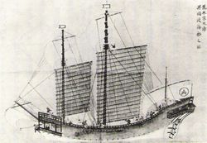
A Red Seal ship of the Araki trading family, 17th century.
The complement was about 200 people per ship (the average of the fifteen Red Seal ships for which the number of people is known, is 236).
The ships were built in various places. Some of them, built in Nagasaki, combined Western, Japanese and Chinese ship designs. ( is the Capital and the largest city of Nagasaki Prefecture in Japan. Others were Chinese junks. And once the trade with Southeast Asia became well established, numerous ships were ordered and purchased in Ayutthaya in Siam, due to the excellence of the construction and the quality of Thai wood. Ayutthaya (full name Phra Nakhon Si Ayutthaya, พระนครศรีอยุธยา aˡjutʰajaː also spelled "Ayudhya" city is the capital of
The ships were managed by rich trading families such as the Sumikura, Araki, Chaya and Sueyoshi, or by individual adventurers such as Suetsugo Heizo, Yamada Nagamasa, William Adams, Jan Joosten or Murayama Toan. Yamada Nagamasa ( Japanese: 山田長政 Yamada Nagamasa; 1590&mdash1630 was a Japanese adventurer who gained considerable influence in Thailand For other people called William Adams see William Adams. Early life Adams was born in Gillingham, Kent, England Jan Joosten van Lodensteijn (c 1560 – 1623 or simply Jan Joosten, was a native of Delft and one of the first Dutchmen in Japan, arriving The funds for the purchase of merchandise in Asia were loaned to the managers of the expedition for an interest of 35% to 55% per trip, going as high as 100% in the case of Siam.

Import and export
Japanese merchants mainly exported silver, diamonds, copper, swords and other artifacts, and imported Chinese silk as well as some Southeast Asian products (like sugar and deer skins). Silver (ˈsɪlvɚ is a Chemical element with the symbol " Ag " (argentum from the Ancient Greek: ἀργήντος - argēntos gen Copper (ˈkɒpɚ is a Chemical element with the symbol Cu (cuprum and Atomic number 29 Silk is a natural Protein Fiber, some forms of which can be woven into Textiles The best-known type of silk is obtained from cocoons Pepper and spices were rarely imported into Japan, where people did not eat a great deal of meat due to the local preponderance of adherents to the Buddhist belief system. Black pepper ( Piper nigrum) is a flowering Vine in the family Piperaceae, cultivated for its Fruit, which is usually dried A spice is a dried Seed, Fruit, Root, Bark or vegetative substance used in Nutritionally insignificant quantities as a Food additive Southeast Asian ports provided meeting places for Japanese and Chinese ships.

Destinations
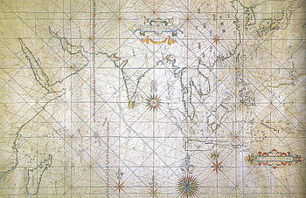
Japanese portolan sailing map, depicting the Indian Ocean and the East Asian coast, early 17th century. The Indian Ocean is the third largest of the world's Oceanic divisions covering about 20% of the water on the Earth 's surface
The crew of the red seal ships were international, for many Chinese, Portuguese, and Dutch pilots and interpreters joined the sails. The first Red Seal ships were required to have a Portuguese pilot on board, although the Japanese progressively developed pilots of their own. The Portolan maps used on the Red Seal ships were drawn on the Portuguese model, with directions in the Japanese language. A portolan (derived from the Latin word portus, port is an early modern European navigation chart, dating from the Thirteenth century or later
Major Southeast Asian ports, including Spanish Manila, Vietnamese Hoi An, Siamese Ayutthaya, Malay Pattani, welcomed the Japanese merchant ships, and many Japanese settled in these ports, forming small Japanese enclaves. Hội An is a small city on the coast of the South China Sea in the South Central Coast of Vietnam. Ayutthaya (full name Phra Nakhon Si Ayutthaya, พระนครศรีอยุธยา aˡjutʰajaː also spelled "Ayudhya" city is the capital of Pattani ( Thai ปัตตานี is one of the southern provinces ( changwat) of Thailand.
The Japanese seem to have been feared throughout Asian countries:
"The Japons are not suffered to land in any port in India (Asia) with weapons; being accounted a people so desperate and daring, that they are feared in all places where they come" (Sir Edward Michelbourne, Boxer, p268).
A Dutch commander wrote (circa 1615): "they are a rough and a fearless people, lambs in their own country, but well-nigh devils outside of it".

Religious http://www.casawomo.com/essays/filial-piety-in-chinese-religion

Filial Piety in Chinese Religion

by Robert Reese, 2003
Filial piety was an integral part of Chinese culture and therefore was embraced by three of China's main religions: Confucianism, Buddhism, and Daoism. Among the three, Confucianism, with its well documented social hierarchy, supported the ideals of filial piety the most. Buddhism and Daoism also supported filial piety in some of their texts, but had monastic systems that prevented monks and nuns from being filial children.
The term filial piety refers to the extreme respect that Chinese children are supposed to show their parents. It involves many different things including taking care of the parents, burying them properly after death, bringing honor to the family, and having a male heir to carry on the family name (Brians 1). Practicing these ideals is a very important part of Chinese culture. Therefore, one would expect that filial piety would be incorporated into the major religions of China as it has been.
The ideal of respecting and behaving properly towards one's parents fits perfectly with Confucianism's ideal of respecting and behaving properly towards all elders. Confucius himself addressed the subject in the Analects:
When your father is alive observe his intentions. When he is deceased, model yourself on the memory of his behavior. If in three years after his death you have not deviated from your father's ways, then you may be considered a filial child. ("Confucian Teachings" 20).
According to Confucius, respect to one's father while he is alive is a given -- something that even animals do. But, to be a filial child, one must respect his parents even after their death. Confucius goes on to cite further specific examples of what a filial son should do for his parents. Among them, children should never offend their parents, never speak badly of them, not travel far away without purpose, always be conscious of their parents age, and protect them whenever necessary (21). These things were not all that was required of a filial child. Rather, they were an just a few rules that Confucius' disciples felt were important enough to be included in the Analects.
The concept of filial piety was exhibited in other Confucian texts as well, such as the Book of Rewards and Punishments. Although this text was technically a popular religious text, rather than a Confucian one, it highlighted many Confucian ideals, such as filial piety. It describes good, virtuous people seeking immortality as those who "exhibit loyalty to their ruler, filial piety to their parents, true friendship to their older brothers" (143). Contrarily, those who are evil "insult their ruler and their parents behind their backs" (143). According to this text, it is impossible to be a good, virtuous person without showing respect for one's parents. The inclusion of filial piety in this popular religious work also helps to show how widespread the belief in filial piety was in China. Although it received a great deal of support and promotion from Confucianism, filial piety was not limited to Confucians -- it was a widespread part of Chinese culture.
Filial piety is also mentioned in Buddhist texts. In the Mangalasutta, it is said that the love of the parents "can never be compensated even if one were to carry one's parents on the shoulder without putting them down for a hundred or a thousand years" (Hallisey 246). Here, it is explained that the reason for filial piety is to show gratitude and attempt to repay one's parents for the tremendous amount of love and caring that they devoted. The text also mentions more specific examples of how a child can show respect for his or her parents, such as bathing them and providing them with food and drink (245).
Although many Buddhist and Daoist texts support the idea of filial piety, their monastic intuitions lie in direct opposition to one of the main responsibilities of a filial child -- having a male heir in order to carry on the family name. Precepts of the Perfect Truth Daoist Sect says that "All those who choose to leave their families and homes should join a Daoist monastery, for it is a place where the body may find rest" (146). Both Daoist and Buddhist monks were required to leave their parents behind to live a cloistered life, an action that certainly does not concur with the concept of filial piety. Furthermore, they are required to remain celibate and can therefore not have any children. Without having children, one cannot have a male heir to carry on the family name. Because having a male heir is a core component of filial piety, a Buddhist or Daoist monk can not be a filial son.

Social http://www.vedanet.com/index.php?option=com_content&task=view&id=56&Itemid=2&limitstart=4
The Tribe of Quraish on the Eve of Islam
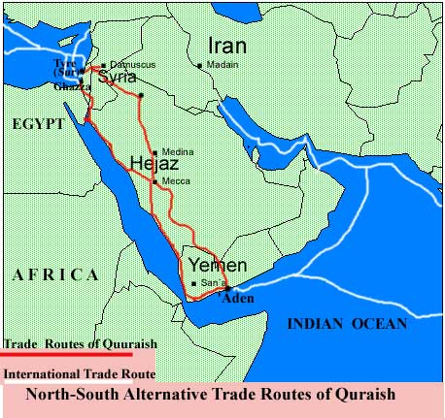
● The tribe of Quraish, has settled at Mecca, an ancient sanctuary and halting place in the middle of the trade route between Syria and Yemen, since about a century and half before the rise of Islam around 610 A.D. Not only the people of Quraish have assumed the role of the custodians of the sanctuary of Ka'bah after ousting its earlier keepers Banu Khuza'ah, from Mecca, but have contributed much to the popularity and traffic to this shrine by introducing many improvements in its organization under their famous leader Qusai bin Kilab around the middle of the 5th century of the Christian era.
● Mecca, the name itself probably derived from a word meaning sanctuary, being situated in a totally barren surroundings, was unable to support its inhabitants from any produce of its soil, making them to rely for their livelihood on the visitors to the shrine of Ka'bah or their situation of lying on the North-South trade route, which very soon induced Quraish to assume a direct role in its benefits.
● This trade route which eventually became a source of considerable significance for Quraish, so as it has been pointedly referred in a chapter of the Qur'an as an special favor of God upon the tribe of Quraish, was in fact a link in a long and major trade highway, connecting eastern and western parts of the globe from ancient times. It was through this route based on the seas and oceans in the south of Asia, that the products of China, South-East Asia and India, mainly, found their way in the markets of West-Asia and Europe in a considerably safe and highly cheaper way. As it happened, a spurt in the long drawn wars between the Empires of Rome and Iran at the beginning of the 6th century, turned the Iraqian link of this trade route as impractical transferring the whole commercial traffic through Red Sea via Egypt to the Mediterranean, or through the North-South land trade-link running along the western coast of Arabia. This land-link, passing through Mecca and increasingly being monopolized by Quraish with the advance of the 6th century, was more preferable, when sound and safe, because of the navigational hazards of the Red Sea.
● The increasing prosperity of Quraish and the inclination to corner the spoils of the above mentioned trade-link by it, in comparison to other affiliated tribes, and by selected families within Quraish, in comparison to other sections of the tribe, in the decades before the rise of Islam, was resulting in a conflict of interests which, if, on the one hand can be seen in the inter-tribal wars of the like of Fijjar, could also be observed in the tension prevailing between the strong and weaker sections within the tribe of Quraish itself. The rise of Islam in this scenario, with an emphasis on economic and social justice, had a strong appeal for those being deprived in the economic system of the Quraish while it augured danger to the profiteers, hence, their strong opposition to it.
Intellectual
Citadels http://en.wikipedia.org/wiki/Citadel
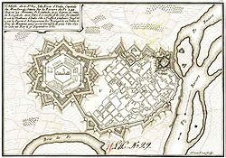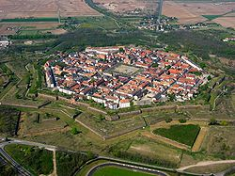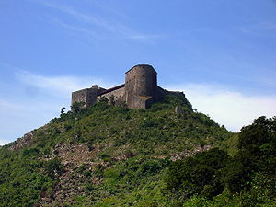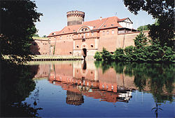

Arts
To Rebel is to Justify http://sites.asiasociety.org/chinarevo/?p=38
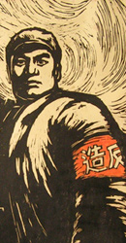Three months after the official launch of the Cultural Revolution in May 1966, one million youths gathered at Tiananmen Square to attend Mao’s first meeting with Red Guards. The Red Guards were a mass movement of civilians, initially radical high school and university students. Their manifesto stated that they wanted to turn the old world upside down, smash it to pieces, pulverize it, create chaos and make a tremendous mess, the bigger the better! Red Guards were encouraged to be revolutionary through the destruction of the four olds: the old ideas, old cultures, old customs, and old habits of the exploiting classes. Across the country, art schools and universities were closed down and cultural heritage and antiquities were destroyed. One estimate cites that 4,922 of the 6,843 officially designated places of cultural and historical interest in Beijing were destroyed, mostly in 1966. The following year, Red Guards began to stage large-scale public art exhibitions. The drawings, paintings, posters, and woodblock prints in this section convey the fervor of what could be considered one of the largest and most destructive youth movements of the twentieth century, concurrent with those in Paris and Berkeley.
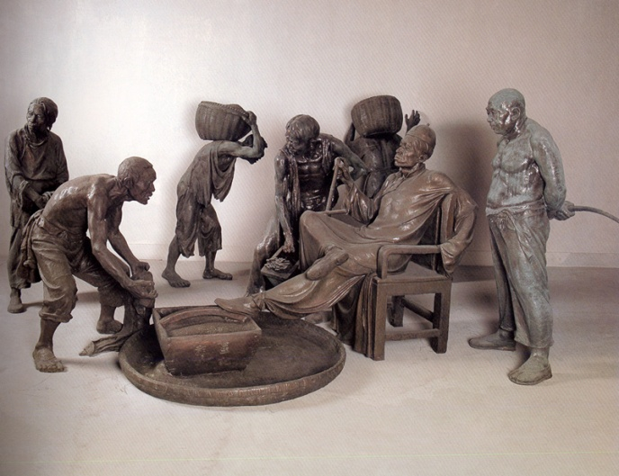
Rent Collection Courtyard
1974
Fiberglass
Dimensions Variable
Art Museum of Sichuan Fine Arts Institute
Enlarge
Rent Collection Courtyard is a tableau of 114 sculptures originally created in 1965 by teachers and students from the Sichuan Fine Arts Institute. The sculptures illustrate the payment of grain by farmers in Sichuan province to their landlord. The obvious exploitation of the peasants here is designed to remind viewers of the unfairness of feudal China, thereby providing justification for revolution. The original sculptures toured extensively throughout China and reproductions were made. It is said that the work was seen by two million visitors. In a testament to the work’s iconic status, contemporary artist Cai Guo-Qiang staged his own recreation entitled Venice’s Rent Collection Courtyard at the 1999 Venice Biennale, where it won the Golden Lion Prize.
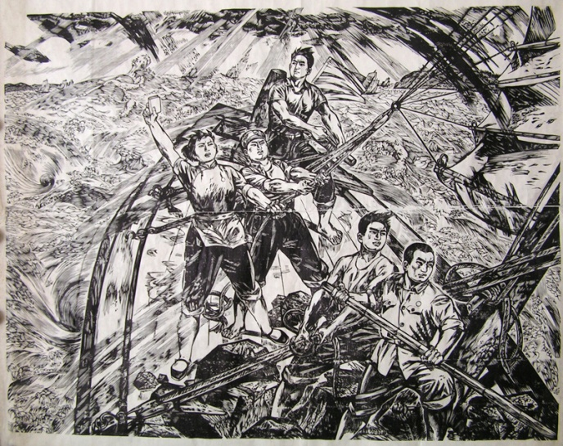
Jiang Tiefeng 蔣铁峰 (born 1938)
Using Mao’s Thought to Fight with the Storm
1973–74
Woodblock print
57 1/16 x 63 in. (145 x 160 cm)
Collection of Yao Zhonghua
Enlarge
This woodblock print was based on a news report about a group of students caught in a storm at sea. As the story was related, the students held fast to Mao’s Little Red Book to survive the rough waters and regain control of their boat.
Jiang Tiefeng graduated from the Central Academy of Fine Arts and taught at the Yunnan Art Academy. Today, he is one of China’s most well-known children’s book illustrators and lives in San Diego.
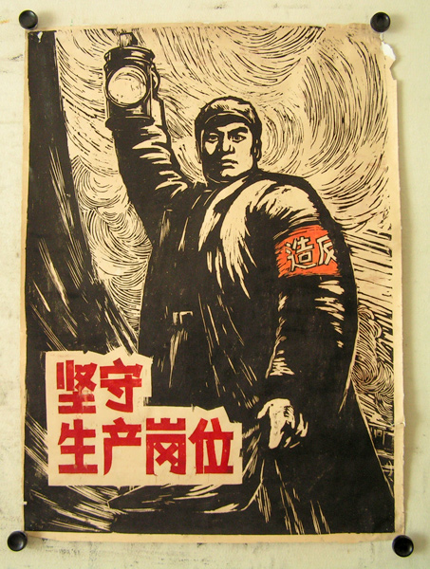
Ma Zhensheng 马振声 (born 1939)
Standing Firm on Production Work Post
1966
Woodblock print mounted on rice paper
41 3/8 x 29 9/16 in. (105 x 75 cm)
Collection of Yao Zhonghua
Enlarge
This woodblock print was made in the early years of the Cultural Revolution to encourage workers to fulfill their revolutionary responsibilities by remaining at their jobs instead of leaving them to participate in the Cultural Revolution.
Ma Zhensheng graduated from the Central Academy of Fine Arts in 1964 and studied under renowned painter Jiang Zhaohe (1904–1986).
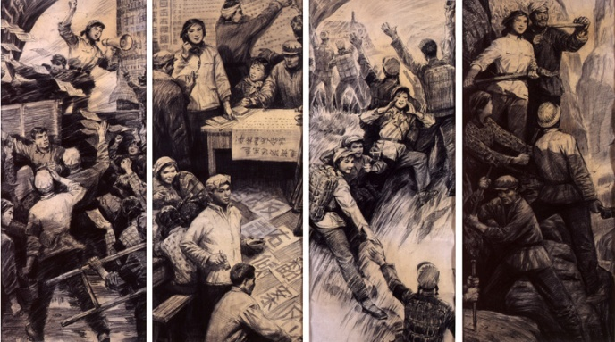
Zhang Songnan 張頌南 (born 1942)
Youth
1972
Four panels, charcoal on panel
30 5/16 x 13 13/16 in. (77 x 35 cm)
Collection of Xue Song
Enlarge
This four-panel drawing depicts some of the Red Guard activities at the beginning of the Cultural Revolution.
Zhang Songnan graduated from the Central Academy of Fine Arts in Beijing and later worked there as a professor in the Mural Department and as Assistant to the President. He immigrated to Canada in 1988 and currently lives in Montreal. Tang Xiaohe graduated from Hubei Institute of Fine Arts in 1965 and currently lives in Wuhan.

